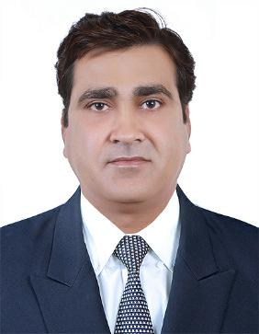
Gururaj

Address: UAE

E-Mail: gururaj.380107@2freemail.com

For the attention of: The HR Manager

Dear Sir/Madam,

I am writing to outline my overall over 18 years of experience in handling various profiles involving project management, sales

- marketing and business development. I believe I possess the skills, qualifications and vital experience necessary to make a very significant contribution to your organization.

I am a Project Management & Business Development Professional. My core competencies include skilled in implementing strategies to enhance business volumes and achieve growth by analyzing & assessing revenue potential. Successfully integrated solid management, business development, personnel leadership and technical expertise in pursuit of goals and objectives. In depth technical knowledge of valves including gate, globe, check, butterfly, diaphragm, plug valves, etc. as well as in market research and knowledge of new projects as well as in commercial terms & conditions.

As you will note from my enclosed CV, I had significantly realizing for sales booking from oil & gas projects, tank farm projects including valves, pipes & fittings in UAE as per the approved goals. Managed overall gross profit margin on the sales in line with company policy and effectively maintaining & generating new potential customers and all the existing clients. Analyzed market strategies for the stock order prediction and negotiating stock order with various vendors as well as recognizing potential clients and focused to promote stock business.

Accountable for project scheduling including material & manpower planning. Participating in project review meetings for evaluating progress & resolving the areas of bottlenecks. Anchored various activities to ensure completion of project within stipulated time & budgeted cost parameters and effective resources utilization to maximize the output/profit. Linked with internal and external clients on determining technical specifications, approvals for smooth execution & obtaining on-time clearances to expedite the work progress.

I am now looking for a challenging role in a reputed organization. Being a focused, motivated and goal-oriented professional, I have consistently proven my ability to handle diverse responsibilities in crisis and pressure, while operating under rigorous deadlines. I am sure I can deliver similar results in your organization.

I have 10+ years UAE work experience in Oil & Gas, Tank Farms, Power, Marine and Water Sector including 5 years of experience in Abu Dhabi region.

Please do not hesitate to call me on +971 504820755 so we can arrange an interview to discuss my application in greater depth. I look forward to hearing from you.

Yours faithfully,

Gururaj

enc.: Resume

UAE

gururaj.380107@2freemail.com

Gururaj

Project Management & Business Development Professional
Professional Profile

performance driven professional with over 17 years of experience in handling various profiles involving project management, sales & marketing and business development

In depth technical knowledge of valves including gate, globe, check, butterfly, diaphragm, plug valves, etc. as well as in market research and knowledge of new projects as well as in commercial terms & conditions

Adept at identifying, sourcing and evaluating potential vendors coupled with excellent skills in consensus building, organization, and price negotiation, tendering and estimating long term and profitable contracts management

Skilled in implementing strategies to enhance business volumes and achieve growth by analyzing & assessing revenue potential. Successfully integrated solid management, business development, personnel leadership and technical expertise in pursuit of goals and objectives

Proven skills in mapping market dynamics to draw vital inputs to facilitate marketing/sales strategies to combat competition & sustain leadership position

True team leader, mentor and a motivator with fine-tuned analytical & troubleshooting skills and superior communication abilities

Thrive in a deadline intensive environment, multi-task, perform under pressure and meet deadlines. Goal-oriented, systematic planner with a big-picture perspective

Key Skills:

Project Operation
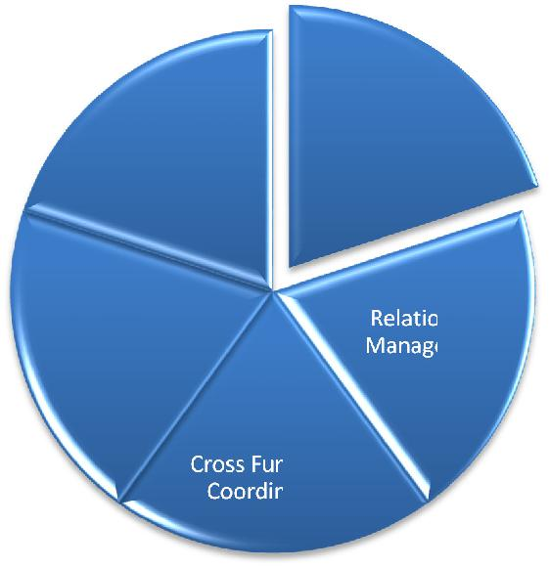
Management Management

Business Strategic
Development Planning

 |  |  | Team
 |  | Client | Management
 |  | Satisfaction
Sales & | Budgeting
Marketing
 | Negotiating
Vendor
 | Quality Control
Development |  | Analytical
 |  | Skills
Product | Market |  | Functional
Development | Intelligence
Manpower | Policy &
Management | Procedures

CAREER REVIEW

Nov 2017 – Present: United Piping Solutions DMCC, Dubai as Manager- Internal Sales

Key Deliverables

Significantly realizing for sales booking from oil & gas, Power, & Water Projects including All types of Vales in UAE as per the approved goals

Managing overall gross profit margin on the sales in line with company policy and effectively maintaining & generating new potential customers and all the existing clients

Analysing market strategies for the stock order prediction and negotiating stock order with various vendors as well as recognizing potential clients and focusing to promote stock business

Recording & procuring work process with the support of end-users, EPC & consultants as well as focusing on the product marketing for organization products as well as agency products with end users, EPC & consultants

Liaising for approval of technical documents, negotiating on commercial terms and finalizing the orders on various vendors. Overseeing project orders / Stock Orders / Shut Down Requirements / Annual Rate Contract & clients by following:
  - Commercial terms & price negotiations

  - Appropriate and right vendor selection for the various products

  - Exclusivity / agency agreement from vendors

  - Enlisting of “UPS” with end users and consultants

Interacting with various departments such as Contracts / Logistics, QA / Servicing, Accounts Internally, Clients, Consultants and Vendors

Accountable for project scheduling including material & manpower planning. Participating in project review meetings for evaluating progress & resolving the areas of bottlenecks

Anchoring various activities to ensure completion of project within stipulated time & budgeted cost parameters and effective resources utilization to maximize the output/profit

Linking with internal and external clients on determining technical specifications, approvals for smooth execution & obtaining on-time clearances to expedite the work progress

Jan 2017 – Sep 2017: Dutco Tennant LLC, Dubai as Key Account Sales Engineer

Key Deliverables

Managing the entire UAE Sales Territory for Oil & Gas & Marine sector.

Frequent visit to Customer/ EPC/ End User for introducing Dutco & Agency Products.

Looking for the Principals of the approved/ reputed brand & sending introduction/ approaching for agency into UAE/ Mideast region, already achieved in getting some of the Principals into DUTCO basket.

Finding out the Ongoing/ Upcoming Projects through MET (Mideast Tender Website)/ Project Information Sites or visiting the Client/ EPC, for Tender/ Awarded jobs, approaching the Client/ EPC for the enquiry of the Product which falls in our Dutco Range & getting the enquiries.

Studying the received enquiry & getting the quote from the appropriate supplier/ Principal & timely submission of our quotation, handling TBE & Technical Clarification

Looking after the registration & Prequalification of Dutco & Agency products with all the major clients/ End Users/ EPC. Online Tendering/ Bidding to the End Users & EPC.

Studying the Market Requirement by visiting the customers & various stockiest for stocking the fast moving products. Maintain the stock of the same to cater immediate stock requirements (Maritime and Oil & Gas).

Interaction with all other departments like Finance, Operations, Logistic, Warehouse for timely execution of orders. Have experience & worked for Dutco Web catalogue preparation for Oil & Gas and Maritime product ranges.

Aug 2007 – Dec 2016: Econosto Mideast BV, Dubai as Senior Sales Engineer

Key Deliverables

Managing the UAE/ Abu Dhabi Sales Territory, also handled the sales activity for Iran region during 2007 & until 2010 (before US & EU sanction).

To achieve sales booking from oil & gas projects, tank farm projects (Valves, Pipes & Fittings) in United Arab Emirates, Abu Dhabi as per the agreed targets.

To achieve overall gross profit margin on the sales in line with company policy.

To generate new potential customers & send Introduction for Econosto & Agency Products and to retain all the existing clients. Looking for the ongoing & upcoming projects (through MEED projects) & awarded EPC for that project, find the possible

potential Products which falls under Econosto/ Agency scope of supply, approach the EPC & generated the Enquiries, Study the enquires & submit our competitive offer, Handling the TBE/ Technical clarification.

Online Tendering/ Bidding to major end user like GASCO, ZADCO, ADMA, ADNOC, ADWEA, ADAC, etc & EPC like NPCC, Technip, etc.

To study the market for the stock order prognosis. Negotiate stock order with various vendors. Identify potential clients & to focus and promote stock business.

Looking for the Potential products & their Principals. Study, Approach & apply for the agency agreement of the principals in Abu Dhabi Region.

To focus & work on the registration, Prequalification, enlisting of Econosto & various other Agency Product with end-users from

Abu Dhabi region with all the ADNOC group of companies includes ADMA-OPCO, ADCO, ZADCO, GASCO, ADGAS, Takreer,

Borouge, ADNOC- Dist, ADWEA and other major client like ADAC, ADPC, NPCC, Technip, Petrofac, Tecnmont, etc, other major EPCs & consultants.

To focus on the product marketing for Econosto products, as well as agency products with End users, EPC & consultants. To approve technical documents, negotiate on commercial terms and finalise the orders on various vendors.

Interacting with other Dept. like Purchase, Contracts, QA, Logistic, Finance & arrange the Cross Review Meeting if required for the smooth Executions of the Project Orders.

Attending various trade shows, Exhibitions and events to promote our brand of products.

SKILLS, KNOWLEDGE & EXPERIENCE:

In depth technical knowledge of valves (Ball, Gate, Globe, Check, Butterfly, Double Block & Bleed Plug Valve (Twin Seal type), Diaphragm, Plug Valves, MOV, ESDV, etc]

In depth knowledge of commercial terms & conditions

In Depth Knowledge about the Online/ Manual Registration, Pre-Qualification/ Approval & Online Tendering of the Econosto & Agency/Principal product into all the ADNOC group of Companies, Major EPC and consultants with 5 years experience.

Market research and knowledge of new projects and competitors Good verbal and written communication skills & negotiation skills Comprehensive problem solving abilities

Ability to deal with people diplomatically Willingness to learn new things and adapt Team facilitator

KEY CHALLENGES

This position in Econosto Mideast BV has a few challenges as mentioned below while handling project orders & clients

Commercial terms & price negotiations.

Appropriate and right vendor selection for the various products Origin clarity and approval

Exclusivity / agency agreement from vendors

Online Tendering/ Bidding skills for GASCO, ZADCO, ADMA, ADNOC, NPCC, Technip, etc

Enlisting of Econosto as a supplier & Pre-Qualification/ Approval of the Agency product of our Principal with all the ADNOC group of Companies, Major EPC and consultants.

PAST EXPERIENCE

Jan 2001 – July 2007: BDK Group of Companies, Hubli (Now part of WEIR Group) as Engineer – Intl Sales

PERSONAL DETAILS

Date of Birth: 24th Oct 1975 | Nationality: Indian

Linguists Abilities: English, Hindi, Kannada and Marathi

REFRENCES AVAILABLE UPTO REQUEST

