MOHAMMED
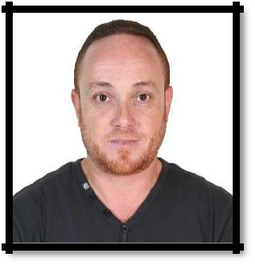
Nationality: ALGERIAN
Mohammed.380115@2freemail.com

Civil Engineer Manager

PROFESSIONAL EXPERIENCE

Engineer team leader Control:

EGIS International, Jijel - Algeria. Since May 2016.

- Team Leader Control at the entrance way project of the Highway Djen-Djen (Jijel) - El Eulma (Setif) over 110Km.

o Control and monitoring of road construction and attachments over a 24 Km’s section all with necessary annex works.

Main tasks performed:

• Monitoring of work and drafting of inspection PV.

• Compliance with the execution file.

• Verification and validation attachments and quantities.

Chief Civil Engineer

National Agency of Dams and Transfer, Jijel – Algeria (September 2009 to April 2016)

- Head of the project of Water Transfer between the dam of Tabellout (in Jijel) and the the one at Draa Diss (in Setif) with 05 large pumping stations and 42Km of steel pipe, in addition of 04 transformer stations 60Kv, 01 source post transformer 220Kv and 100Km of electric lines with various types of pylons.

- Leader of the project of the deviation of the trunk road RN77. The project consists on :

- Carrying out 02 viaducts of 1 Km each with the stakes height varies between 80 m and 120 m
- 6 Km of the road
  - Ancillary works (culverts, pipe culverts and box culverts).

- Ensure the follow-up of civil engineer work and the execution file respect and make technical modification decisions.

- Supervising constructions and managers on-site.

- Activity reports.

- In-factory tests: KSB (Germany) for hydraulic equipment’s (pumps), March 14 -19, 2011.

Technical Manager

Office of Engineering Design Architecture and Urbanism, Jijel – Algeria 2009

- Executions studies and specifications of projects and construction methods.

- Follow-up of work on-site and decide of requirements of projects.

- Draft agreements.

- Study and evaluate submissions concerning construction projects.

Engineer Manager

Promotion and Property Management, Jijel – Algeria 2008

- Execution studies and specifications.

- Recommendations on building materials.

- Supervise managers on-site.

- Activity reports.

Project Manager

Hydraulic Company Boukedira Noureddine, Jijel – Algeria 2008

Civil Engineer

Popular and Communal Assemble of Jijel, Jijel – Algeria 2007

Civil Engineer

Company of Buildings Lourci Samir, Jijel – Algeria 2006

Educational Background

- BSc Degree in Civil Engineering (Roads and Construction)

University of Setif, Setif – Algeria. 2005

End of the studies’ project on the topic of: “Study of a multi-beams bridge pre-stressed concrete”.

- Baccalaureate in Exact Science.

Jijel - Algeria. 1997

 |  |  | LANGUAGES
• | Arabic : | Write : very good | Read : very good
• | French : | Write : good | Read : good
• | English : | Write : medium | Read : medium

OTHER SKILLS AND INTERESTS

- Traineeship on the Bill of quantities at the Superior National School of Hydraulics (ENSH) Blida (Development of a bill of quantities, Study of prices and public contract)

- Traineeship on Dams and Transfers Techniques at the Superior National School of Hydraulics (ENSH) Blida.

- Traineeship of First aid – C.R.A

- Driving Licence.

- Took part on the 1998's Census.

- Information technology and sport …

