- Name: | Sunil
- Age: | 35 Years Old
- Sex: | Male
- Photo: | 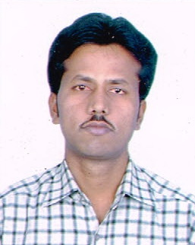
- Date of Birth: | 3rd January 1981 (35 Years Old)
- Marital Status: | Married
- Nationality: | India By Birth
- Religion: | Hindu
- Language: | Gujarati, Hindi, English.(Write and Speak)
- Work: | Aluminium Fitter & Fabricator
- Skills: | Ms-office, Internet browsing as well as computer operator
- Objective | Looking forward to a challenging and rewarding position in the industry by utilizing my Technical and managerial skills to the optimum and growing along with the company
- Work Experience: | Above (7) Years as main cutting and fitting supervisor of aluminium fitter fabricator work. Operating of auto double miter saw machine; end mill; and copyright machine. I am handling of cutting department. Also assemble and insulation of all types of doors and windows like open able; top hung; French windows etc.
- Work History: | ( 1 ) As aluminium Fitter and Fabricator in CEO Cosmo Enginee. Co.Ltd. in 2007 at New Delhi. ( 2 ) As aluminium Fitter and Fabricator in Daynight Engg. & Contr. Pvt. Ltd in 2009 at New Delhi. ( 3 )Present Working: Bhavya aluminium in Dist. Rajkot (Gujarat)
- Extra Curricular Activity: | To acquire knowledge of latest technology regarding aluminium Fitter & Fabricator works

