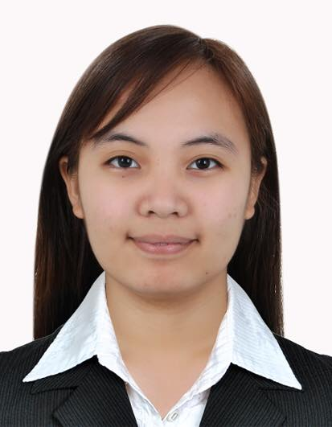
JOANNA
E-mail: Joanna.380164@2freemail.com
DUBAI, UAE

OBJECTIVES

- To be able to apply and enhance my experience in Information Analysis, Data monitoring and Billing/Invoice Processing.
- To be able to contribute to the success of the company I will work for while equipping myself with the foundation I need to have a successful career in my chosen field.

WORK EXPERIENCE

Industrial Engineer / Information Analyst (May 2017 – March 2018)
Mayapa CBK Industry, Inc., Calamba, Laguna, Philippines

Key Responsibilities:
- Creates process flow chart using MS Excel for all running process in company.
- Monitors data from production using MS Excel. (Ex. Number of finished goods ready for delivery and Quantity of raw materials withdrew from warehouse)
- Analyze total cost per project. (Actual cost versus Estimated cost)
- Creates sales invoice per billing of finished projects.
- Assigns Reference number to be used by operators in production.
- Releases a copy of Reference Documents (Drawing & Material Breakdown) to production and supervisor.

CERTIFICATION

Certification Examination for Industrial Engineers – Passer
December 2016

Basic Occupational Safety and Health (BOSH)
December 2016

INTERNSHIP TRAINING

Linaheim Corporate Services, Inc.
Corporate Quality and Business Process
Service Engineer Trainee
NAIA Complex, Parañaque City
April 2016 – July 2016

EDUCATIONAL ATTAINMENT

Tertiary : Batangas State University Main Campus I
General Engineering (SY 2011-2013)
Batangas State University - Alangilan Campus
BS Industrial Engineering (SY 2013-2016)

Secondary : Gov. Feliciano Leviste Memorial National
High School (SY 2007-2011)

Primary : Mahayahay Elementary School (SY 2000-2007)

PERSONAL BACKGROUND

Date of Birth : June 22, 1995
Place of Birth : Lemery, Batangas, Philippines
Age : 22
Civil Status : Single
Citizenship : Filipino
Height : 5'4’'
Weight : 73kg
Languages Spoken : Tagalog / English
Skills : Microsoft Office
: Microsoft Visio
: Time and Motion Study
Visa Status : Visit Visa

