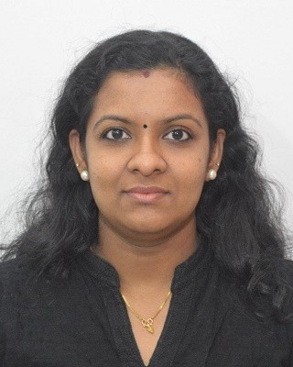DEEPA

MOH Qualified Pharmacist
Sharjah U.A.E.

E-mail: deepa.380166@2freemail.com

Aiming to be associated with recognized progressive pharmaceutical organization in research and development that gives me scope to upgrade my knowledge, research and management skills in accordance with the latest trends and be a part of a team that dynamically works towards the growth of the organization
CAREER OBJECTIVE

Ammu Medicals, Varkala, India. Sep 2015 — Apr 2017
WORK EXPERIENCE
Pharmacist

Performed drug dispensing and review of any ADR.
Well known about the billing section and the pharmacy store management.
Thorough knowledge regarding the pharmacology of the drugs, its uses and adverse reactions.
Patient counseling regarding the use of the drugs, use of OTC drugs etc.

Gowri Medicals, Trivandrum, India.
Pharmacist

Apr 2011 — Oct 2013

Critical analysis of the prescriptions and dispensing of drugs.
Consistently upheld proper pharmacy and general safety procedures and standards. Provided critical information and advice to customers regarding possible drug interactions side effects, dosage and proper medication.
Maintained proper storage and security conditions for all drugs. Inventory Control.

Bachelor of Pharmacy [B.Pharm] from Department of Pharmaceutical Sciences, Cheruvandoor, Kottayam, Kerala in 2008 (M.G University).
ACADEMIC QUALIFICATIONS
All India Senior School Certificate Examination (CBSE) from M.G.M Model School, Varkala-Kerala in 2003.
All India Secondary School Examination (CBSE) from M.G.M Model School, Varkala-Kerala in 2001.

MOH Evaluation Certificate
LICENSE
Issued Date: 13/03/2018

Clinical Practice and Hospital Pharmacy training at Taluk Head Quarters Hospital, Changanassery - Kerala.
TRAINING AND PROJECTS
Attended ward rounds, critical analysis of prescriptions, patient history interview.

Patient counselling. Provided drug information.

Carried out a prospective study of anti-inflammatory character of Glycosmis Pentaphylla and submitted to Mahatma Gandhi University, Kerala.

Interpersonal Skills
CORE COMPETANCIES
Analytical, Logistic & Creative Skills.
Excellent Communication.(English, Hindi and Malayalam) People Management & Time Management.
Selling skills & Customer Service skills.

MS Office.
COMPUTER PROFICIENCY

PERSONAL | Date of Birth : | 07/07/1985
 | Nationality : Marital Status : Visa Status : | Indian Married  Residence (Husband's visa)
References available upon request.
REFERENCES

I do hereby declare that the above stated particulars are true, complete and correct to the best of my knowledge.
DECLARATION

(Deepa)

