Curriculum vitae

ENGR. TAHIR
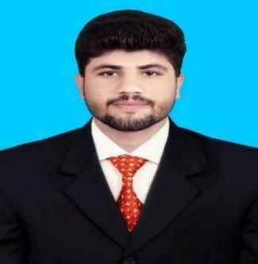

PERSONAL INFORMATION

tahir.380175@2freemail.com

Dubai, UAE

Sex Male | Date of birth 04/04/1993 | Nationality Pakistani

JOB APPLIED FOR

Mechanical Engineer

EDUCATION AND TRAINING

Bachelor of Science in Mechanical Engineering

CGPA 3.08/4 (2016)

COMSATS Institute of Information Technology

Registered Engineer

PEC NO: MECH/33761

My objective

To seek a challenging task in order to refine my talent and capabilities where I can express and exchange knowledge with others and make myself learned and successful person. I want to work in Research and Development.

Technical Expertise

Having good command on AutoCAD.

Having good command on MS Office.

Having basic knowledge of MasterCam

Professional Work Experience

Production and Planning Engineer in Volta Dies and Mould

(Injection molding)

(September 2016- March 2018)

Major Customers

- Honda Atlas o Haier
o SNGPL

Responsibilities

Plan and daily regular check of execution of the planning.

Production Engineer to ensure that quality of products is according to standard.

Production engineer to evaluate material requirement and arrange for

Adequate Material supply to meet the required target.
.

In case of some unavoidability ensure that alternative is available so that The production process is not hampered.

Communication skills –

Communication skills gained as Proctor in the university.

Leadership skills experienced as Head Proctor in the University.

Good organizational skills gained as a member of science club.

Good team-leading skills gained as cricket team captain

Final Year Project:

Conversion of Conventional Carburetor Bike Engine into E.F.I Technology Engine performance and comparing efficiency of both Carburetor and E. F. I

Internship

Summer internship in Northern Power Generation Company (GENCO III), Faisalabad. (August 2015- September 2015)

