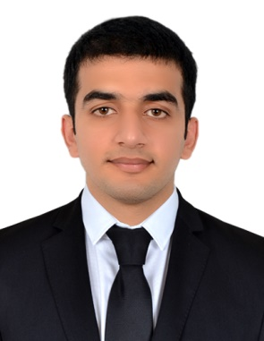

Expertise
- Computer Operations
- Cash Handling
- Computerised Accounting
- MS Word & Excel

Education

- Bachelor in Computer Sciences
Punjab Group of Colleges G.T. Road, Jhelum, Pakistan (2013-2015)

- Certificate of Office Management (MS Word, MS Excel & MS Power Point)
Al-Falah Community Centre, Jhelum, Pakistan

- Basic Certificate of Web Designing (HTML, CSS, Adobe Dream Weaver & Macromedia Flash)
Computer City, Civil Lines, Jhelum, Pakistan

- Certificate of Computerised Accounting (Peach Tree and Tally ERP 9)
Computer City, Civil Lines, Jhelum, Pakistan
FARHAN

Email: farhan.380193@2freemail.com

ABOUT ME
I am a flexible person seeking employment which will allow development, growth and make use of my existing skills. I am highly motivated and passionate to pursue my professional career to the next level. I have completed my bachelors in 2015. I worked at two different organisations as a Data Entry Operator and Accounts Officer at DASKTECH (SMC PVT) LTD. Jhelum, Pakistan and KDC Plywood Factory (PVT) LTD. Jhelum, Pakistan respectively. I have the experience of Computer Operations and Accounts work with English communication skills. Please take your time to check my Resume. I will provide all the necessary documents if needed.

PROFESSIONAL EXPERIENCE
- Accounts Officer
Company: KDC Plywood Factory (PVT) LTD. Jhelum, Pakistan
Duration: 1st July 2016 to 15th June 2017
I joined KDC Plywood Factory in 2016 as a Data Entry Operator and after 3 months I was promoted as the Accounts Officer under the supervision of Senior Accountant. We dealt in wood works.
My job description includes:
- Data Entry
- Preparing Daily Production Reports on MS Excel
- Cash Handling
- Submitting daily cash flow report to Assistant Manager
- Banks Dealing (Cheque cash, Cheque deposit, Cash Deposit etc.)
- Creating Vouchers
- Book Keeping and closing at the end of the month
- Entries of vouchers at Company’s Software
- Letter Writing
- Manage Company Email on daily basis
- Completing the tasks before deadline.

PERSONAL SKILLS

Creativity

Organization

Team play

Training

English Communication

Technical Skills

Microsoft Word

Microsoft Excel

Microsoft PowerPoint
HTML
CSS
Typing Skills
Tally ERP 9
Peachtree

CONTACT

farhan.380193@2freemail.com
- Data Entry Operator
Company: DASKTECH SMC (PVT.) LTD. Jhelum, Pakistan
Duration: 1st March 2016 to 30th April 2016
I started my professional career as a Data Entry Operator. I joined DASKTECH in 2016. It was an IT company which provides IT services to their clients from different countries around the globe. It was a very challenging experience and I learned a great deal from it.
My job description includes:
- Worked on different projects assigned by our Team Leaders with other Team Members.
- Letter writing and creating flat files and reports on MS Excel.
- Online Listing on Amazon and EBay.
- Listing on Amazon using Google Translator for writing the data and information of different products for their respective Languages i.e. French, German etc.
- Compiling the work done on daily basis and sending daily report to Team Leaders.

- Personal Information
Marital status: Single
D.O.B: 17-Feb-1992
Languages:
English Moderate
Urdu Native
Punjabi Provincial

