NADEEM  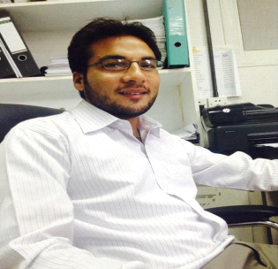  Contact Detail  Email: nadeem.380200@2freemail.com  Personal Data  Date of Birth : 04/04/1992 Sex : Male Nationality : Pakistan Marital Status : Unmarried Religion : Islam  Personal Details  Passport No : GN1164141 Place of issue : Lahore(Punjab) Pakistan  Present Address  CITY : RAS AL Khaimah COUNTRY : United Arab Emirates.  Language: : English  : Hindi, Urdu & Arabic. | Objective  “ To secure a creative, rewarding and challenging career where I can exercise and exploit my knowledge, organizational and interpersonal skills to the best of my ability and thereby work towards the benefit of the organization ”  Academic & Professional Qualification  - Intermediate Computer Science (12th Standard) 2011, Lahore Board  - High School Education (10th Standard) 2009, Lahore Board  Additional qualification  - C.I.T ( Certificate in Information Technology ) From  ( Elite Computer College Kasur )  - AUTO CAD Diploma From  (Boston College Of Management Sciences)  - Adobe Photoshop  Total experience 3 years  - Pakistan experience……..6 Month ……..S  - Saudi Arabia experience…… 2 Years …….  - United Arab Emirates. .... 6 Month..  Employment Record  - Worked as Water jet Operator & Programmer in a Marble Company ( Al-AMRY GROUP FOR TRADING & CONTRACTING CO. DAMMAM SAUDI ARABIA )  - Currently working as Water jet Operator & Programmer in a Marble Company ( Al Rowsha Marble @ Natural Stone ) R.A.K  RESPONSIBILITIES :  - AutoCAD Designing and CNC Water jet cutting machine operating & 2D programming  - KMT high pressure pump maintenance & servicing  - Estimation for cutting time and cutting cost & material.  - Preparation of Quotation word format.  - Following customer blue prints drawings and job instructions.  - Daily production data keep on excel sheet.  - Cutting job inspection using for Industrial measuring tape.  - Monthly production income Updated to Management.  declaration  I hereby declare that all the information mentioned above given by me is true to the best of my knowledge & understanding  Date - Your truly  Place- NADEEM
curriculum vitae

