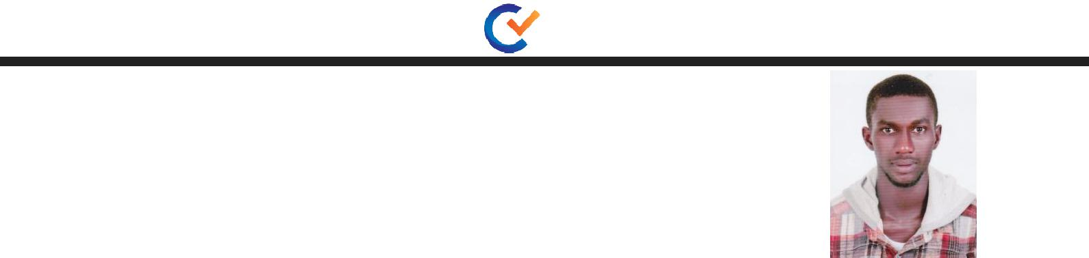
NURUDEEN

Email: nurudeen.380203@2freemail.com

Position: Gypsum Installation Forman

Objective |  | To pursue a challenging career where my knowledge, skills, creativity and abilities can be put to the
 |  | achieving organizational and personal goals
Education |  | High School

KULUNQUNQU Senior High School ,Ghana

Professionalized

- Ducting an Ceiling

- Plan and schedule projects, estimate time and materials, supervise

subordinates, maintain records and file and prepare reports.

- Prepare, schedule and supervise the work layout for the maintenance, alteration and structures and components.

Perform carpentry tasks

. Keep records of carpenters' time and materials used for each job.

Supervise carpentry jobs requiring a high degree of skill.

Provide assistance on complex jobs.

Provide estimates of personnel and material required for a job.

Assign carpenters to jobs, oversee masonry work.

- Requisition materials from warehouse or purchases materials from suppliers.

- Inspect scaffolding and hazardous work to ensure proper safety measures are being observed.

- Keep records and compiles reports of work performed by carpentry crew.

- Perform related work as required.

1

WORK EXPERIENCE

- 4 years experience in Sheikh Aluminum Company Ltd as Forman ,Ghana.

- 10 Month Experience in Winda Arts Intirial Design as Gypsum Worker UAE

Personal Details |  | Date of Birth | : | 25/07/1993
 |  | Nationality | : | Ghana
 |  | Sex | : | Male
 |  | Marital Status | : | Single
 |  | Languages Known | : | ENGLISH, Moderately Arabic

PERSONAL SKILLS

- Communication
- Ability to Work Under Pressure

- Decision Making
- Time Management
- Self-motivation
- Conflict Resolution
- Leadership
- Adaptability
- Teamwork

- Creativity

Declaration:

I hereby by certify that the above given particulars furnished by me are true and accurate to the best of my knowledge.

CHARACTER REFERENCE

Professional and character available upon request

NURUDEEN

