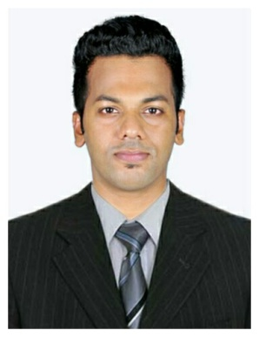
AMAL
An
exHo bet sat
im

Amal.380212@2freemail.com

OBJECTIVE:
To obtain a position in your organization that provides opportunities where I can use my skills and abilities and to make a significant contribution towards the achievement of company’s goal.
PROFILE

An extremely motivated and resourceful, in hospitality with over three years of experience in providing an excellent quality of customer service and Hospitality/ Hotel sectors, showing pride in the service delivered. Ability to coordinate between multi levels to maximize business performance.
- Active learner – Practices good judgment and discretion while working closely with sales managers, firm’s internal departments and customers.
SKILLS

- Proficiency in Computer knowledge such as M.S. Office Word, Power point, Excel, outlook, Computer Basic graphic designing and worked in Hotel software like Fiesta, HMS, IDS, OPERA
- Multi-task efficiently and effectively – Prioritize independently and meet tight deadlines at all costs.
EDUCATION

[2014]B.sc hotel management from Holy Cross Institute of Management and Technology (CALICUT UNIVERSITY) Kerala

[2011]PLUS TWO (COMMERCE STREAM) with an aggregate of 75% from JDT VELLIMAD KUNNU Calicut, Kerala

[2009] 10THwith an aggregate of 63% from VEDA VYASA VIDYALAYAM CALICUT (CBSE SYLLABUS) Kerala

EXPERIENCE
      - FRONT OFFICE SUPERVISOR CUM ADMINISTRATION
(December 2016-August 2017)
PANORAMA GRAND HOTEL (3 STAR HOTEL)

NIGHT AUDITOR
PANORAMA GRAND HOTEL
October 2015 –December 2016
      - FRONT OFFICE CUM ADMINISTRATION
August 2014-august 2015
Hero Honda (Calicut-Kerala)

      - FRONT OFFICE EXECUTIVE (INDUSTRIAL TRAINING)
October 2013 –march 2014
WESTWAY HOTEL, Calicut - Kerala

      - FRONT OFFICE ASSISTANT
06 September 2012- 05 October 2012
Moven pick Hotel & Spa Bangalore (industrial training)

HOBBY’S

- Music
- Road biking
- Love to Travel
- Puzzle
LANGUAGE

- English (written & spoken knowledge)
- Hindi (written & spoken knowledge)
- Malayalam(written & spoken knowledge)

PERSONAL
INFORMATION

Date of Birth : 30/04/1992
Age : 25
Sex : Male
Nationality : Indian
Marital status : single
Issue date : 31/07/2014
Expiry date : 30/07/2024

DECLARATION
I hereby declare that all the above furnished details are true to the best of my knowledge and belief.

