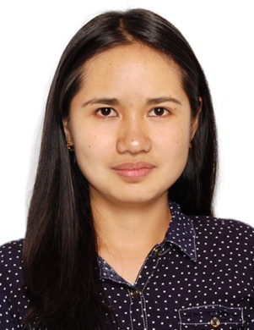
CHRISLYNE
Email: chrislyne.380231@2freemail.com
___________________________________________________________________________________

CAREER OBJECTIVE:
To work in an organization where I am able to give the organization’s growth and profitability with my skills and in turn gets an opportunity to gain exposure and ability that would help me build a strong and successful career.

SUMMARY AND QUALIFICATIONS SKILLS:
- Having 2 years and 2 months experience as Treasurer of a Local Government Unit
- Strong knowledge of MS Office programs, particularly Excel
- Good Communication Skills (English and Filipino)
- Able to work independently and fast learner
- Established working relationships with customers/clients
- Strong organizational skills with ability to multi-task
- Time management skills and the ability to prioritize work
- Working knowledge of office equipment, like printers and fax machines

WORK EXPERIENCE:
- Barangay Local Government Unit (BLGU) Treasurer
January 2016 to March 2018
Kayapa, Nueva Vizcaya, Philippines

- On the Job Training – Finance Staff
Finance and Administrative Services Office of the Department of Science and Technology – CAR
January 2015, to April 2015 – 3 months experience
La Trinidad, Benguet, (Baguio City) Philippines
JOB DESCRIPTION:
- Annual Budget and Financial Statements preparation
- Manage bank accounts, book keeping and record keeping
- Ensure use of funds complies with conditions set by funding bodies
- Manage all filing requirements
- Maintain financial accounting records and cash flow statements
- Processing checks and handle payments and deposits accurately
- Prepare Payrolls for the staffs and laborers and tax computations
- Collect all taxes, fees, other charges and contribution dues
- Prepares vouchers and make payments for the purchases
EDUCATIONAL ATTAINMENT:
- College – Bachelor of Science in Financial Management and Accounting
University of Cordilleras
Gov. Pack Road, Baguio City, Philippines
Year Graduated: April 2015

- Secondary - Kayapa High School
Kayapa Nueva Vizcaya, Philippines
Year Graduated: March 2010

PROFESSIONAL QUALIFICATIONS:
- National Certificate III in Bookkeeping – TESDA
June 25, 2013

- Planning and Budgeting Workshop
September 26 – 27, 2017
PERSONAL PROFILE:
- Date of Birth : July 14, 1993
- Age : 24 years old
- Religion : Christian
- Civil Status : Married
- Citizenship : Filipino
- Height : 5’2
- Weight : 50 kg

REFERENCES:
Available upon request.

CHRISLYNE
(Applicant)

