Head Chef / Sous chef/Sr. CDP
Head Chef with over 12 years of experience including gulf exp: of running highly successful and rated restaurant. Possesses a great and safety record and a wide exposure to various cuisines
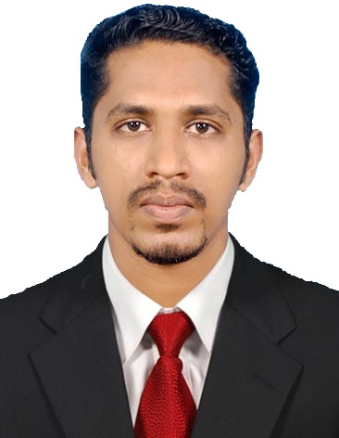
NAZEEM

Email ID: nazeem.380242@2freemail.com

PERSONAL DATA:
Date of Birth: 01-06-1988
Age : 30
Place of Birth: Pathanamthitta
Religion : Islam
Sex : Male
Marital Status: Married
Language Spoken: Hindi, English, Malayalam, Tamil
Passport details
Date of issue : 03/05/2017
Date of expiry : 02/05/2027
Place of issue: Trivandrum

Visa Status: 3 month Visit visa
Location : UAE, Dubai, Bur Dubai

INTERESTS:
Cooking, Bike ride

COMPUTER SKILLS:
- MS Office Word
- MS Office Excel
- Internet Savvy

Professional Experience

Ravin’s Kitchen And Café restaurant Hulhumale Maldives.( 12th October 2017- 21st March 2018)
HEAD CHEF
- Lead junior chef and other kitchen staff in the restaurant in preparing a variety of gourmet dishes for our distinguished customers
- Anticipating culinary trends so that the restaurant keeps and enhance its competitive advantages.
- Managing the day to day administration of the kitchen.
- Keeping within budget when ordering food stock.
- Implementing all relevant food hygiene and safety and food hygiene requirement .
- Create tantalizing recipes for various new dishes on the menu to keep whet the curiosity of customers and keep them coming back for more.
- Monitoring the taste, visual appeal, financial cost and temperature of all meals served.
Fragrant Nature Retreat & Resort , Kollam (1st November 2016 – 04th October 2017)
CHEF DE PARTIE
- Responsible for all kitchen operations including buffets, banquets, room service and the restaurant
- Responsible for menu planning
- Responsible for stock purchasing and cost control
- Ensuring that the standards of hygiene are maintained & improved were possible
Quilon Beach Hotel, Kollam, Kerala (May 6th 2014 – 21st September, 2016)
DEMI CHEF DE PARTIE
- Responsible for all kitchen operations including buffets, banquets, room service and the restaurant
- Responsible for cost control while preparing delicious quality healthy food and thereby gives profit to the organization as well as satisfactions to customers
- Preparing work and ensures that all meals leaving the kitchen are consistent in presentation and quality

Mourya Rajadhani, Trivandrum, Kerala (October 17th 2013-April 24th 2014) COMMIS I
- Responsible for all aspects of the kitchen.
- Creates daily and weekly specials & Cleaning the station.
- Assisting the different station of kitchen

Fairway Catering, Dubai, UAE (4th August 2008 – 23rd September 2013)
COOK
- Responsible for all kitchen operations including buffet.
- Responsible for cost control while preparing delicious quality healthy food and thereby gives profit to the organization as well as satisfactions to customers.
- Preparing work and ensures that all meals leaving the kitchen are consistent in presentation and quality.

Mourya Rajadhani, Trivandrum, Kerala (1st December 2007- 31st July 2008)
Commi II
- Assisting in all areas of the kitchen.
- Preparation of all kind of Indian Cuisine.
- Ensuring correct stock rotation & minimization of wastage.

Sudarshan Hotel, Kollam, Kerala (1st March 2007- 25th November 2007 )
Asst Cook.
- Responsible for all aspects of the kitchen.
- Creates daily and weekly specials.

Samudra Hotel Kovalam, Trivandrum ( 2006 July 1st – 31st December 2006)
Industrial Trainee.
- Assisting in all areas of the kitchen
- Ensuring correct stock rotation & minimization of wastage
- Assisted in the purchase of foods and kitchen supplies.

EDUCATIONAL BACKGROUND
- Diploma : Srinivasa School of Hotel Management, Mangalore , India (2006)
- Plus two : TKM higher secondary school , Quilon, India (2005)
- SSLC : Sivaram NSS HSS , Kollam (2003)

Declaration

I hereby declare that the above -furnished details are true to the best of my knowledge

