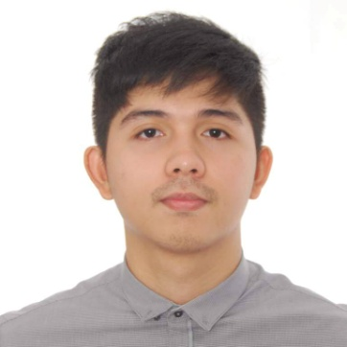
Edward
E-mail Address: edward.380262@2freemail.com

Career Objective :
To obtain a position in the engineering department of a private institution that will help mein improving my abilitiesand gives me an opportunity to learn, contribute and grow along with the organization.

EDUCATION

Tertiary : Holy Angel University
Bachelor of Science in Civil Engineering
#1 Holy Angel Avenue, Sto. Rosario, Angeles City
2012 – 2017

Secondary : Holy Angel University
#1 Holy Angel Avenue, Sto. Rosario, Angeles City
2008-2012

Primary : Holy Family Academy
Sto. Rosario, Angeles City
2002-2008

WORK EXPERIENCE:

AMA Construction – Junior Site Engineer
June 2017 – Dec 2017
Construction of 4 units - Two (2) Storey Residential Apartments

Duties and Responsibilities:

- Checking plans, drawings and quantities for accuracy of calculations.
- Day-to-day management of the site, including supervising and monitoring the site labor force and materials required.
- Taking note of daily activity progress and prepare monthly accomplishment report.

TRAININGS

On the Job Trainee at Gercel Construction and Development Group Inc.
March 2016 – May 2016
Construction of Two(2) Storey Residential Bldg.
Duties and Responsibilities:

- Site Engineer
Site inspection and monitoring the workforce
Taking note of daily progress and prepares weekly progress report
Checking of material deliveries as per the site requirements
- Estimator
Estimate and costing of actual material quantities required in the project

Organizational Affiliations

Philippine Institute of Civil Engineers Student Chapter
March 2014 – 2017

Seminars Attended

Continuing Creation
March 2016
Holy Angel University

Why pursue? Why study? Why Civil Engineering?
September 2014
Holy Angel University

TechnicalSkills

- Uses Microsoft Office(Word, Excel and PowerPoint)
- Has basic knowledge in Autocad

Personal Qualities

- Fast learner and willing to be trained
- Passion for continuous learning and personal growth
- Highly motivated and driven, with strong desire to success

Engr. Edward
Signature

All the representations by me in this data are true to the best of my knowledge and belief. I hereby authorized your company to conduct inquiries about my scholastic.

