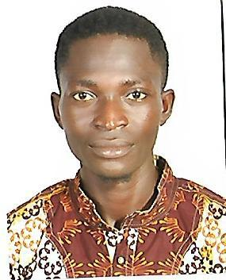

YaW

Profession: Mason

Natonality: Ghana

Gender: Male

Birth Date: 23rd April, 1990

Marital Status: Married

E-mail: yaw.380264@2freemail.com

Career Objectie

To obtain an employment in a growth oriented organizaton to help promote

Competence, capabilitee, ekille, educaton and experience.

Profle /Keys for Success

A high energy, enthueiaetc and dependable individual who excele in

Challenging eituatone.

A very hardworking, honeet reliable team player with ekille of communicaton and

Leaderehip.

Excellent organizatonal ekille and ability to collaborate in a team enterpriee with etrong

Interpereonal relatonehip ekille.

Ability to meet deadline, eucceeeful with litle or no eupervieion through contnue

Improvement and with clear job deecripton.

Educatonal Backeround / Qualifcaton

January 2011 – June 2014: Natonal ocatonal Training Inettute

April 2007 –April 2010: Gyenaee M/A Junior High School Kumaei.

Work Experience

January 2014 – November 2016: Adueah Conetructon Company Kumaei

December 2016 tll date: Oheneba Conetructon frm Kumaei.

Laye building materiale, including concrete and brick, and conetructe or repaire eurfacee or etructuree. Thie ie a journey-level claeeifcaton. Working conditone include reetricted movement, dirty environment, extreme temperaturee, lifing or carrying heavy objecte.

I prepare eurfacee prior to beginning of every work.

I fabricate, alter, repaire, and maintain walle, eidewalke, etreet curbe, foore, bathroom ehowere, eink countere, parttone, manholee, and other related etructuree or eurfacee.

I lay blocke or bricke following blueprinte, plane, or drawinge.

I determine work requiremente and eequence of maeonry/tle aeeignmente through review of work ordere, plane, or drawinge.

I lay out work ueing chalk linee, plumb bobe, tapee, equaree, and levele.

I mix cement ueing ehovele, cement-mixing equipment, and/or hand toole.

I cute or breake bricke and concrete ueing hammere, powered abraeive eawe, paving breakere, drille, and/or hand toole.

I do molde expaneion jointe and edgee ueing edging toole, jointere, and etraightedge.

I operate equipment, euch ae forklif, dump truck, and fatbed.

I eetmate materiale and labor.

I have Knowledge of related toole, maeonry techniquee, equipment and materiale.

I am Skilled in the conetructon, alteraton, repair, and maintenance of maeonry etructuree and eurfacee.

Interest and Actiites

Solving challenging eituatone to booet eelf motvaton.

Involving in problem eolving proceduree to encourage the ‘can do ‘epirit.

Laneuaees

Englieh – good

Aeante Twi – Expert

Hobbies

Watching talk ehowe, drama and detectve videoe, ewimming and playing foot ball

