**CURRICULUM VITAE**

**CURRICULUM VITAE**

|  |
| --- |
| **CAREER OBJECTIVES:** |

To work with leading company and to use my analytical thinking to the best of my ability combined with perseverance so as to contribute to organization’s growth and goal, as well as to attain my professional goal.

|  |
| --- |
| **KEY SKILL:** |

* Good team player
* Easily negotiate with other people
* Have high level of persuasiveness
* Can work effectively in team as well as individually
* Positive approach and motivational support

|  |
| --- |
| **ACADAMIC QUALIFICATION:** |

|  |  |  |  |
| --- | --- | --- | --- |
| **COURSES** | **INSTITUTION** | **UNIVERSITY/ BOARD** | **YEAR OF PASSING** |
| Diploma in Fire and Safety | NIFE | TUV | 2017 |
| HSC | National Institute of open School | Kerala State Board | 2012 |
| SSLC | Sree Vijayeswari HS | Kerala State Board | 2010 |

|  |
| --- |
| **PROFESSIONAL DEVELOPMENT:** |

**IOSH MANAGING SAFETY**

Institution – IIFS

**NEBOSH**

Institution – IIFS (Course Completed)

**OSHA Construction Standard**

Institution – Clovers Safety

|  |
| --- |
| **COMPUTER KNOWLEDGE:** |

* Ms-Office-Word, Excel
* E-mailing
* Working knowledge of Windows and Internet
* Diploma in Multi level Language

|  |
| --- |
| **DECLERATION:** |

I hereby declare that all the information motioned above is true to the best of my knowledge and belief.

Jyothish

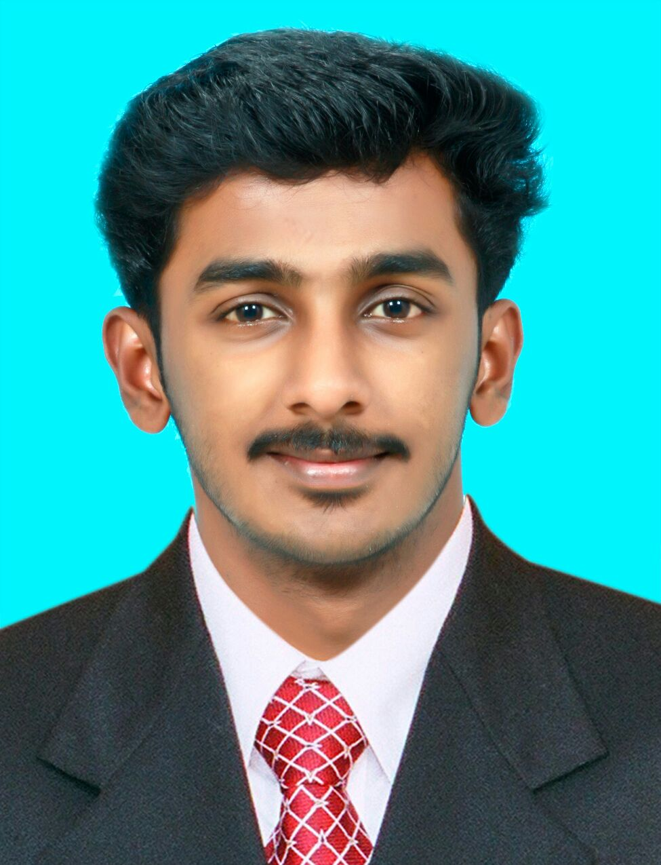

**Jyothish**

**Email:**

[**jyothish.80274_@2freemail.com**](mailto:jyothish.80274_@2freemail.com)

**Personal Data**

|  |  |
| --- | --- |
| Date of Birth | : 10-Sep-1996 |
| Sex | : Male |
| Religion | : Hindu |
| Nationality | : Indian |
|  |  |
| Marital Status | : Unmarried |

**Language Know:**

English, Hindi & Malayalam

**Visa Status**

Visiting Visa