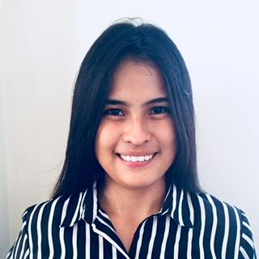
AMERPHIL
Email address: amerphil.380286@2freemail.com

OBJECTIVE: To deliver my duties to the fullest satisfaction of the superiors and subordinates and teach responsible position in the future, work for the betterment of the company in any circumstances.

PERSONAL INFORMATION
Date of Birth: March 17, 1991
Place of Birth: Cebu City
Citizenship: Filipino
Sex: Female
Age: 27years old
Civil Status: Single

EDUCATIONAL ATTAINMENT

Tertiary: University of Cebu
Bachelor of Science in Hotel and Restaurant Management
Sanciangko St., Cebu City
March 2013

Secondary: University of Cebu
Sanciangko St., Cebu City
March 2008

Elementary: Kalunasan Elementary School
Upper Kalunasan Cebu City
March 2004

WORK EXPERIENCE

- UNITED COCONUT PLANTERS BANK
Bank Teller
June 2015-September 2016
Sales Associate
September 2016-December 2017
CICS (Check Image Clearing System)
February 2017-December 2017

- oDesk (online work industry)
Data Entry
Lower Kalunasan, Cebu City
June 2013-March 2014

- Taft Property
Property Specialist
One Mango Avenue, Cebu City
April 2014-June 2014

- On-the-Job Training
Front Office Department
Crown Regency Cebu
Osmeña Boulevard, Cebu City
January- May 2013

- On-the-Job Training
Receptionist/ Front Office Department
Cebu City Waterfront Hotel
Salinas Dr, Cebu City
January- April 2011

Achievement:
SK Councilor (Barangay Kalunasan)
2008-2010

SKILLS

- Possess certain attitudes and qualities to succeed.
- Comfortable giving service to others.
- Approachable and friendly while maintaining professionalism.
- Effective communicator, both written and oral English.

