RESUME

ASAD
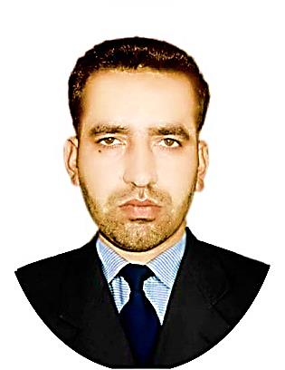
Asad.380295@2freemail.com
Geologist & HSE Certified
SUMMARY
Geology graduate from UAJK Pakistan with professional certifications in health and safety
I.e. NEBOSH IGC, IOSH Managing Safely, HABC Level 2 fire safety and construction material testing certificate having 3 years’ experience in the construction Industry. Currently seeking a challenging position in the HSE a dynamic organization with an aim to contribute towards organizational HSE policies by enhancing competency and ethical standards, to excel consistently and meet the organizational goals.

PERSONAL
INFORMATION

Date of Birth: 28-04-1994

Nationality: Pakistani

Visa: Tourist

PROFESSIONAL SKILLS

- Identifying hazards
- Verbal communication
- Convincing presentation
- Providing Training
- Loss prevention
- Risk Assessment
- Quick Learning
- Work under pressure

LANGUAGES

English
Urdu
Arabic

PROFESSIONAL EXPERIENCE

December 2014 HSE OFFICER
To December 2017
(3 years) CGGC CHINA (CONTRACTOR)
Neelum Jehlum Hydro power Project Muzaffarabad, A.K Pakistan.

Most substantial duties

      - To conduct Tool box talks meetings
      - To inspect the site to ensure that it is a hazard free environment
      - To verify that tools and equipments are safe to use
      - To promote safety practices at the work site
      - Doing risk assessments
      - To handle safety signage
      - Personal protective equipments

EDUCATION

Sep. 2011 to Dec. 2015 B.S Applied Geology (4 Years) CGPA – 3.67
University of Azad Jammu & Kashmir Muzaffarabad AJK Pakistan

2009 to 2011 HSSC Pre Engineering (2 years) with 73% Marks
Punjab College of Commerce, Rawalpindi Pakistan

2007 to 2009 SSC (Science) (2 years) with 87% Marks
Read Foundation College Dhirkot, AJK Pakistan

AWARDS & CERTIFICATES

- Three months construction material testing course from KRL, Pakistan.
- OSHA 30-Hours General industry U.S.A
- IOSH Managing Safely U.K
- HABC level 2 Award in fire Safety
- NEBOSH international General Certificate U.K
- Award from university on Best Essay Writing
- Six Months computer basic and professional course.
- Received Gold medal in the SSC.

