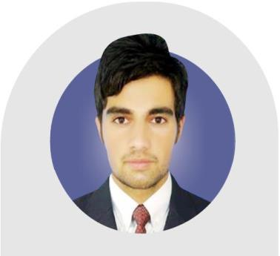
Ijaz

Electrical Engineer

Email: ijaz.380307@2freemail.com

Profile

A dedicated Electrical Engineer with extensive knowledge and experience in designing of Electrical distribution system, designing of drainage system, water supply, Etisalat and Nat Gas. installation of Electrical distribution system, cable laying, cable termination, Conduting, Lightning protection and cable try installation, testing of LT and HT bus Bars, testing of LT and HT switchgears, testing of transformers, Alpha Boards, Distribution boards and battery Bank System.

Volunteer to gain practical experience and management issues in work by utilizing a logical and logical approach to find the best outcome. Considered to be a good communicator, who is able to negotiate effectively to achieve company objectives and goals. Well-regarded as a strong leader and good team player who is able to set-out formal processing procedures and develop comprehensive schedules of work to ensure the safe and timely completion of tasks.

Education & Professional Certifications

- Bachelor of Science in Electrical Engineering, Pakistan

- Registered Engineer, RE # ELECT/57315: Pakistan Engineering Council (PEC) Islamabad, Pakistan.

- Registered by HEC Pakistan.

Professional Experience: +2years

Company: China State Construction & Engineering Corporation (CSCEC), Pakistan Branch

1st August 2016-till Nov 2017

Designation: Electrical Site Engineer

Duties and Responsibilities:

- Designing of Electrical distribution system as per client and consultant.

- Supervising the site.

- I was a part of Testing and commissioning team, there I done testing of LT and HT bus bars, HT and LT switchgears, Transformers, Alpha Boards, Distribution boards and Battery Bank System.

- Do correspondence with Consultants and Client if required & tackle issues with Consultants with full dedication and resolve all the issues of site.

Page 1 of 3

Company: AL SAHEL ENGINEERING CONSULTING

Nov 2017 – April 2018

Designation: Electrical Engineer

Duties and Responsibilities:

- Designing of electrical distribution drawings.

- Designing of drainage system drawings.

- Designing of water supply drawings.

- Designing of Etisalat drawings.

- Designing of Nat Gas drawings.

- Dealing with clients.

- Consulting with contractors and sub contractors and resolving site issues.

- Site progress visit each week and discuss with clients.

- Dealing with SEWA inspecting team.

Professional Skills

- Electrical Designing on AUTO CAD software.

- Innovative thinking and influencing leadership, handle multiple tasks with minimum supervision

- Effective negotiation skills

- Power world simulator

- MS Office (Excel, Power point, Word)
- Proteus
- MATLAB Basics (for Power Systems)
- CISCO Packet Tracer

Personal Attributes

- Receptive approach i.e. Persuading and Influencing

- Excellent written and verbal communication skills i.e. Writing and reporting

- Applying expertise and technology

- Analyzing

- Learning and researching

- Following instructions and procedures to ensure attention to details and displays initiatives

- Committed to deliver results and meeting customer expectations

- Sound interpersonal & relationship building skills

- Team oriented but also able to work as an individual

- Ability to solve any problem efficiently and precisely in a given field

Page 2 of 3

Training By CSCES Staff Pakistan Branch

- Training for shop Drawings Designing by using AUTO CAD.

- Training of cable Calculation, Load Calculation, Estimetation of different materials and different material plans by respective MEP Engineer.
- Training of Safety by Overseas Safety Manager (CSCECL).

Personal Details

- Nationality - Pakistani

- Languages
  - English

  - Urdu

  - Pashtu

- Date of Birth – 12 June, 1993

- Marital Status - Single

- Visa Status - visit visa

Page 3 of 3

