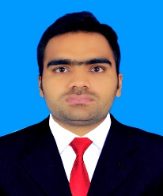
MOHSIN
MECHANICAL ENGINEER
mohsin.380319@2freemail.com
CAREER OBJECTIVE:

Being a Mechanical Engineer, I am hopeful to be a part of meaningful and challenging environment which enriches me with knowledge and skills. I want to contribute my talent and Innovative skills for development of the company and shape myself as sagacious professional while serving the organization.

CAREER PROFILE/SKILLS:

- 2 year Experience in Construction Company
- Effective communication skills both verbal & in writing.
- Working knowledge of the following software programs: AutoCAD & HAP etc.
- Develop fabrication drawings
- Work as a Proposal Engineer
- Experience in Motor Bike and Tractor manufacturing industries

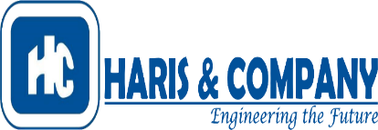
PROFESSIONAL WORK EXPERIENCE:

Organization: Haris and Company (Pvt.) Ltd.
Tenure: June 2016 – December 2017
Designation: Planning Engineer
Projects: DG-Cement HUB Baluchistan (Structure)
PC-Hotel Structure (Mirpur, Azad-Kashmir)
Hascol Oil Storage Depots, ZIC Oil Depots (Sahiwal)
Safe City Project (The Government of the Punjab)
Lahore Kidney and Liver transplant Hospital (Shed)
Responsibilities:

- Plan different fabrication projects
- Deal with Tanks and other Complex geometries
- Sand Blasting monitoring
- Work on capacity development, specification of standards on different projects in Pakistan.
- Introduce myself with the industrial piping system
- Technical support on different piping system of Industrial, Building & Infrastructure level.
- Design most of the structural elements by using different Soft wares
- Work on project specification according to specification of consultant, Contractor, Client end.
- Stress Analysis
- Monitor QA/QC Department
- Deal with Welding Procedure Specification (WPS)
- Radiographic Testing (RT) of different profiles
- Excellent knowledge on plumbing specifications of Apartments building, Hotels, Hospitals, Shopping malls, infrastructure, Educational institute’s etc.
- Know pipe system installation as per specification given by Consultant.
- Completed all the projects in accord with specific standard of the consultants.
- Develop Fabrication Drawings of PC-Hotel Structure Project Mirpur, Azad-Kashmir

Organization: Atlas Honda (Pvt.) Ltd.
Tenure: Less than a year
Designation: Trainee
Project: CNC Machine Chip Conveyor

- Learn different Computerized Numerical Control Machine Processes (Drilling, Shaping, Boring, knurling, Threading, Tapering, Turning etc.)
- Inspect Heat Treatment Processes (Carburization, Quenching, Tempering etc.)
- Learn different Casting Processes (Gravity Die Casting, High Pressure Die Casting and Low Pressure Die Casting )
- Learn about Vapor Absorption Cycle, Vapor Compression Cycle, Heat Exchanger and Cooling Tower
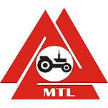
Organization: Millat Tractor (Pvt.) Ltd.
Tenure: Less than a year
Designation: Trainee

- Learn about the 4-Strokes of the Tractor Engine
- Analyze MF-260 Power points
- Understand how their Hydraulic System works
- Steering Assembly and Power Steering Working Principle
- Valve Timing and Cam’s working

ADDITIONAL SKILLS:

- Event organizer while working with Professional Layyan’s Society as a President of the Society
- Worked as a Finance Secretory of the aforementioned Society
- Member at the American Society of Mechanical Engineers
- Successful Experiment of Air Powered Engine (Suzuki 80cc) under the supervision of ASME

ACADEMIC EDUCATION:

Degree | Examination Body | Year | Performance
BSc. Mechanical Engineering | University Of Engineering & Technology, Lahore | 2012-2016 | CGPA: 3.30
F.Sc Pre-Engineering | Ibn-e-Khaldoon Higher Secondary School, Layyah | 2010-2012 | Percentage: 88
Matriculation | Ibn-e-Khaldoon Higher Secondary School, Layyah | 2009-2010 | Percentage: 90

PERSONAL INFORMATION:

Date of Birth : 08 August 1994
Driving License : Having Pakistan valid driving license
Religion : Islam

