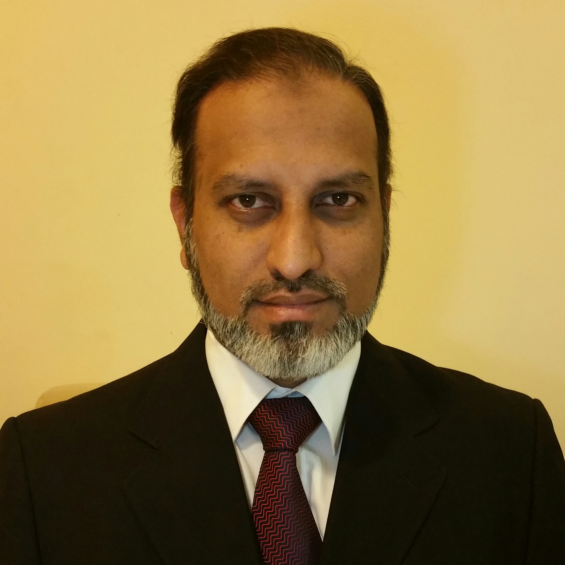
Fakroddin
E-mail: fakroddin.380333@2freemail.com

Career Objective
A self-determined person and an active team player who likes to lead by example and is driven by success.
Seeking a challenging career in the Retail sector to get a position of responsibility, using my professional skills and efficiency to communicate my ideas and views and commit myself for achieving organizational objectives with the team effort and my positive attitude and performance.

Experience | Professional
Al Futtaim Group (February 2015 – Present)

E-Commerce Division, Dubai, U.A.E
An Al Futtaim Group Company & part of Retail Chain representing Online stores for all Al Futtaim
Retail Brands like Plugins, Ace, M&S, Robinsons & Toys r us.

Sales Operations Executive

- Set & follow Order fulfillment process in the Ecommerce operations function.
- Assisting Plug-ins Electronics Purchasers to procure stocks for Online Customer through Authorized Vendors
- Providing a seamless multi-channel / Omni-channel transaction / experience to customers working in partnership with the other eCommerce teams, Retail Operations, Logistics, Contact Center, IT and Finance amongst others to ensure the very best service experience is offered to customers. B to B & B to C.
- Report directly to the Order Fulfillment Manager in eCommerce & senior Management within the Al Futtaim Retail Division.
- Establish or monitor specific supply chain-based performance measurement systems, Develop and be an active participant in Sales and Operations Planning (S&OP) process.
- Ensure Company is in compliance with laws and regulations regarding transportation
- Providing administrative support to a management team in a fast paced Al Futtaim retail environment.
- Assisting Operations manager on E-Commerce daily activities for Business to Customers throughout the supply chain management & Sales Operations, includes pricing, availability & delivery.

Al Futtaim Electronics, Abu-Dhabi, U.A.E (2005-2015)

An Al Futtaim Group Company, Authorized distributor for international brands like
Panasonic, Toshiba, Aftron, Sanyo, York A/c, Fagore, Nokia, MS Product, Candy &
Hisense Brand of Consumer Electronics.

Sr. Sales & Marketing Coordinator (Abudhabi & Al Ain)

- Order processing & follow-up with logistics for timely delivery 3PL, to business partners in the regions.
- Invoicing & POD Submission to Key Account outlet. Monthly accounts reconciliation & account adjustments with respect to services & returns, sales, responsible for order management, accounting and shipping.
- Supply & maintain PSI for 5 Costless Showrooms & services on daily weekly & monthly bases.
- Ensure supply of key marketing & Sales promotion models implemented timely in all key account outlets.
- Support New products launch & dealer seminars in liase with principal companies.
- Coordinate training for business partner along with training manager & ensure partner attendance
- Follow set goals & instructions for respective business partners Key Accounts outlets and monitor performance accordingly
- coordination with all Local Dealers, Mass Merchandisers & power retailers regularly update information of new products prices & features to all business partners, Merchandiser in all outlets, Stock /Sales Planning, to be responsible for all aspects of the sales development, maintenance and execution.
- Ensure smooth operations in absence of Branch Sales Manager to achieve branch sales targets from sales executive.

LG Electronics Gulf, Dubai, UAE (June 2003 – January 2005)
LG Electronics Gulf FZE, A US $ 50 billion Korean Global leader & MNC in
Consumer Electronics Manufacturer. Trading in Electronics, IT Communication
products with Regional office at JAFZA for MENA Region

Sales & Marketing Coordinator (PC Division, OSD, CRT & LCD)

- Purchase Coordination & order follow up from Indonesia, Korea & china factories.
- PSI check & manage for all MENA LG Distributors for OSD, CRT & LCD Monitors.
- Forecast Sales & Monitoring sales for Dealer channel & power retailers, Generating corporate Business from Banks, oil Companies, Government Departments in liase with local & international Business partners.
- Reporting & advising competitor’s models, price, features & brand to LG H.Q & their marketing activities
- Creating Marketing ideas for successful promotions such as GITEX, DSF, DSS & Ramadan promotions.
- Ensure smooth operations in the absence of Regional Product Manager
- Coordinating with all departments within & outside the organization

Alpina Computer Design, Dubai, U.A.E (May 2001 – June 2003)
A startup reputed organization in the field of IT, providing Hardware, Software & Networking
Solutions, Executive Business Solutions for H.R and Payroll Management, Turnkey Business
Solutions, Financial Accounting Solutions, E.R.P. Solutions and Customized Programming for
Local Market

I.T Sales & Marketing Coordinator.

- Organizing software sales presentations (seminars/demos)
- Feasibility Study, analyzing client software requirements, client coordination, order processing
- Outstanding collections, business follow-up
- Preparing sales reports, ensure proper documentation, service follow up subject to AMC

Dalmia Samsung Sangyong Mobile Communications LTD. (D.S.S) (Oct 1998 – 2001)
An ISO 9001 Certified Multinational Company in the business of wireless and
Telecommunications, pioneered as India's largest paging and mobile phone service provider.
Leasing Call centers for some the MNCS like Samsung, Philips, HP, BPL, Videocon, HSBC,
Mercedes, Hyundai etc.

Customer Relation Executive

- Service co-ordination for mobile & paging subscribers including brands like Nokia, Motorola, Ericsson & Siemens
- Supervising Call center Team, Interacting with call centre customers. Prepare & maintain duty roaster
- Operating paging software & resolving customer complaints.

Core Expertise
- SAP – System Application Program - Sales & Distribution Module
- MS Office, DOS, Word star, Internet Fundamentals

Qualification | Professional
Certifications

Diploma in Advance Web Technologies
SSI Institute of Technology Bangalore, India

Qualification | Academic
1998 - B.Sc. Computer Science
R.B.A.N.M.s First Grade College
Bangalore University, India

1993 - Secondary School Leaving Certificate (S.S.L.C), Karnataka State Board
Indira Nagar Higher School
Bangalore – India

Skills | Intrapersonal
- Training and Presentation Skills
- Ability to perform confidently under immense pressure and achieve the set targets.

Languages
- English
- Hindi
- Urdu

Miscellaneous
Date of birth | June 12, 1976
Nationality | Indian
Visa status | Employment (Transferable)
Driving License | Dubai
Marital Status | Married

Reference
Available on request.

