RESUME
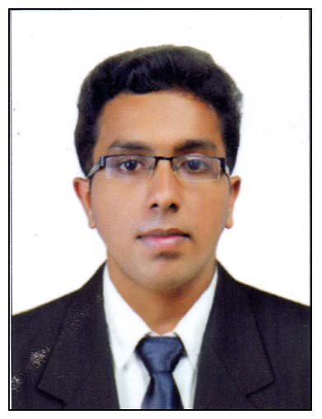
DEEPU

EMAILID: deepu.380334@2freemail.com

Objective:
To grasp more knowledge and to get more exposure with honest attitude at your property.

Personal Information: Date of birth : 22th –April-1995

Professional Qualification:

Year | Degree | Affiliation | Institute
2013 - 2016 | Completed 3 year degree in B.sc Hospitality  And Hotel Administration | NCHMCT  &  IGNOU | Oriental School of Hotel Management, Lakkidi Wayanad, Kerala.

Academic Qualification

Year | Degree/ Certificate | Institute | Percentage of Marks  obtained
2012-2013 | 12th (State) | DON BOSCO SCHOOL,MONVILA,  TRIVANDRUM | 59 %
2010-2011 | 10th (state) | ST.JOSEPH H S S  TRIVANDRUM | 71 %

Area of Interest: FOOD & BEVERAGE PRODUCTION

Experience: 6 months training experience in VIVANTA BY TAJ, BEKEL FORT, KASARGOD, KERALA, INDIA from 1st June 2014 to 1st November 2014.
1 month training Commi 3 experience in THE CAPITAL HOTELS AND RESORT, PULIMOODU, TRIVANDRUM, KERALA from 28th August 2016 to 1st November 2016.

One year experience as a job trainee at RELAIS & CHATEAUX NIRAAMAYA RETREATS, KOVALAM, TRIVANDRUM, KERALA from 1st December 2016 – 1st December 2017.

About myself: Honest, hardworking and with a right attitude towards life. I am obedient, since, Good Qualitative Aptitude Along With Good Grasping Power and Eagerness to Learn, Self-motivation and passion to succeed

Languages Known : English, Malayalam and Tamil.
Achievements:
- Participated in the Seminar Conducted by HACCP(August 2013)
- Participated in the Seminar conducted by YIELD.
- Participated in the drawing competition conducted by gastronomy club.
- Participated in one day Bartending seminar conducted by Mr. Varun Sudhakar.
- Conducted Theme dinner ‘CHRISTO FEST” in ORIENTAL SCHOOL OF HOTEL MANAGEMENT, LAKKIDI, WAYANAD, KERALA.
- Participated Three Days- Interface Meet On Food Safety & Public Health ( phase1) Conducted by KERALA VERTNARY & ANIMAL SCIENCES UNIVERSITY , POOKODE, WAYANAD
- Participated CHRISTMAS CAKE MIXING CEREMONY in THE GATEWAY HOTEL, CALICUT , KERALA
- Participated outdoor catering service from THE MUTHOOT SKYCHEF, TRIVANDRUM, KERALA

Hobbies: playing tabla and mridangam, drawing, miniature crafter , playing badminton
Activities: Travelling, Cooking

Declaration
I hereby declare that all the information given above is correct at my best knowledge.

