Syed 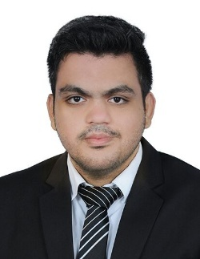
Email: syed.380335@2freemail.com

Objective:Seeking a challenging position in the field of sales ,marketing and accounting so asto utilize my skills for organization and individual growth.

Experience

Organization: ZARS International, Hyderabad, India
Duration: Oct 2015 – Dec 2017
Role:Payroll Executive and banking relation executive
- Process all the weekly, monthly, quarterly, half -yearly and yearly payrolls of all the employees of the organization
- Manage the year-round bonus and half -yearly appraisals given to the employees and check their entries in the account book
- Verify other payroll related entries and resolve the queries of the management team
- Handling current account
- Handling requests for bid bond , performance bond and L/c

Education
- MBA(Finance & Hr) from Amjad Ali Khan College of Business Administration
- B.com(Hons) from Aurora Degree college
- Intermediate from Sri Srinivasa junior college
- SSC from St. josephs High School

Academic Projects
- Company: ICICI Bank
Project title: Analysis of Mutual Fund
Description:
Study and analyze Open-Ended Balanced growth schemes of five mutual funds and to compare
and rank each of them
Giving investor an idea on mutual fund and its working in the market with illustration
To help investor have understanding of the risk associated with mutual fund investment

Company: Hero MotoCorp
Project title: Cash management and its effectiveness

Description:
Study of cash management in general.

Study of effectiveness of cash management using intra firm comparison of Hero MotoCorp

Achievements
- Did promotions for Samsung for its newly launched cell phones
- Volunteered as an organizer for the biggest LiteratureFestival of Hyderabad HLF
- Attended one month of “English for employability” programme conducted by US consulate.

Technical Skills
- Windows XP, 7, 8, 10
- MS Office
- Tally

Skills & Abilities
- Good Communication Skills
- Able to Work Independently and With the Team
- Hardworking, goal-oriented, Adaptive, Sincere and Supportive

Personal profile
- Name: Syed

- Date of Birth: 22nd October 1992

- Nationality: Indian

- Language known: English and Hindi

Declaration:
I hereby declare that the particulars given above are true to the best of my knowledge and belief.

