GOKUL
Gokul.380356@2freemail.com
Mobile: Whatsapp +971504753686 / +919979971283

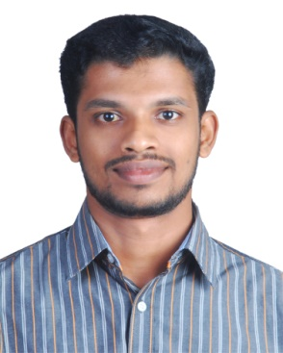
OBJECTIVE
To work in a professional work driven environment to build a career within it and where I would get opportunities to prove myself by accepting the challenges, fulfilling the organizational goals and climbing the career ladder through continuous learning.

PROFESSIONAL EXPERIENCE

Junior Engineer

Ray Engineering Limited.
02 May 2016–31 July 2017

Job Description
As a Junior Engineer in Integrated Refinery Expansion project (IREP)at BPCL – Kochi Refinery

EDUCATION

Bachelor of Engineering (Civil)
Anna University – Chennai, India.
Passed with First Class (CGPA 7.02) in 2016.

12 – CBSE
SreeNarayana Central School, Mavelikara , Kerala, India.
Passed with 66% in 2012.

10 – CBSE
Vidhyadhiraja Vidhyapeedom Senior Secondary School, Mavelikara, Kerala,India.
Passed with 8.2 CGPA in 2010.

PROJECT

An experimental investigation on partial replacement of fine aggregate as copper slag in concrete.

IT PROFICIENCY
- Auto CAD (CIVIL)
- Auto CAD 3D
- Revit Architecture
- Microsoft Office Package
- Internet browsing

ACADEMIC HONOURS&EXTRACURRICULAR
- As someone with exceptional leadership qualities, nominated as Representative, a position that held responsibility in bridging the communication gap between my mates.
- Active participant and volunteer in almost all aspects.
- Executive Member of Event Organizing Committee in Maria College of Engineering and Technology

INTERPERSONAL SKILLS
- Hard worker while creative.
- Comprehensive problem solving abilities.
- Always owed with “can-do spirit”.
- Quick learner, resourceful, productive, and with good sense of humour.
- Decision-making leadership, acceptance of responsibility and evidence of team-work.
- Able to work independently, as a part of team, able to vaporize and grasp new things quickly.

PERSONAL DETAILS
Nationality : Indian.
Gender : Male.
Date of Birth : 20 September 1993.
Marital Status : Single.

Languages : English, Malayalam, Tamil & Hindi.

Visa Status : Visit Visa (Valid till 06 June 2018)

DECLARATIOn
I hereby declare that the above-mentioned information is correct up to my knowledge and I bear the responsibility for the correctness of the above-mentioned particulars.

GOKUL

