





CONTACT ME

**THANSIH**



––

EDUCATION



**B.TechMECHANICAL ENGINEERING**

Government Engineering College, Kozhikode University of Calicut Passed with CLASS: FIRST

**PROFESSIONAL EXPERIENCE:**

Iam currently working as MEP ENGINEER (MECHANICAL) at PROMPT ENGINEERING CONSULTING SERVICES. TRISSUR, KERALA (DECEMBER 2016 – MARCH 2018)

* Work with the BIM MEP Modelling Team under the guidance of the BIM Engineering lead
* Review the input drawing and models and prepare the list of queries to the costumer.
* Produce the desired deliverables in the form of coordinated models, clash reports, etc. As per the requirements and the BIM
* Assist the BIM Engineering lead to finalize the schedule of deliverables and the BIM execution plan.

MECHANICAL ENGINEER

OBJECTIVE

Seeking a challenging and rewarding position in mechanical engineering and modelling or construction industry where i can integrate my technical and analytical skills that will lead to advancement of my responsibilities and knowledge and to pursuea successful, challenging and exciting career while BHIM able to dispense my maximum potential to the benefit of the organization and at the same time acquiring knowledge on the road to success.







COMPUTER PROFICIENCIES

[Thansih.380362@2freemail.com](mailto:Thansih.380362@2freemail.com)

* Revit
* Autocad
* Navisworks
* Creoparametrics
* MS Office
* Programming in C

DOB: 20th FEB 1995



LEADERSHIP



* Co-ordinator of Mechanical Technical fest RIOGA, Govt. Engineering College Kozhikode
* Co-ordinator of B-zone fest, Calicut University

LANGUAGES KNOWN

Fluent in English Elementary in Arabic Fluent in Malayalam Fluent in Hindi



MECHANICAL ENGINEER

THANSIH

I hereby declare to bear the responsibility for the correctness of the information given in the resume.

DECLARATION

STRENGTH

* Effective communication
* Good leadership quality
* Expert in implementation project
* Excellent client and intercompany relationship
* Good coordination power
* Innovate new ideas to improve existing technology

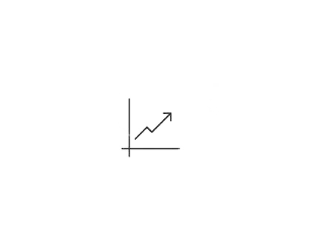

THANSIH