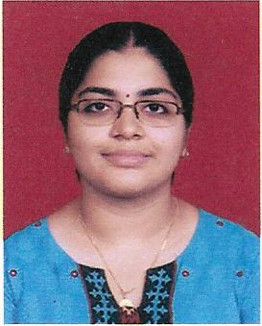
Name: Divya
E-mail: divya.380378@2freemail.com
OBJECTIVE:
To live my dream as an outstanding teacher in the educational sector by embracing the teaching profession at a reputed educational institution and to achieve career growth through sincere efforts and excellent performance, consistently.
ACADEMIC EDUCATION:
- Master of Commerce in Advanced Accountancy from Vivek College of Commerce (University of Mumbai) – May 2016. Secured ‘A’ Grade (GPA: 6.50).
- Secured 3rd Place in the College – M. Com - University Examination.
- Bachelor of Commerce in Financial Accounting and Auditing from LN College (University of Mumbai) – March 2014. Secured ‘A’ Grade (CGPA: 6.56).
- Secured 2nd Place in the University – T.Y. B. Com (V Semester) - University Examination.
- HSC from Kendriya Vidyalaya (CBSE), INS HAMLA, Mumbai – August 2011. Secured 52% marks.
- SSC from Kendriya Vidyalaya (CBSE), INS HAMLA, Mumbai – May 2009. Secured 67% marks.
KEY SKILLS:
- Excellent Communication – Spoken & Written – 1st prize in Inter-Collegiate Essay Writing Competition (Arth Utsav 2012, organized by Planning Forum) in August 2012. 2nd prize in Inter-Collegiate Elocution Competition conducted by the A.D. Shroff Memorial Trust in November 2012.
- Flair for teaching – Passed ‘Train the Teacher’ Programme in Teachers Training Academy conducted by the Maharashtra Class Owners Welfare Association, Mumbai, scoring 65.5% marks.
- Leadership qualities – Was the School Discipline Captain and the School CCA (Co-Curricular Activities) Captain for two consecutive years (HSC level) at Kendriya Vidyalaya, INS HAMLA, Mumbai.
- Good knowledge of “Graphology”,
- Highly focused.
WORK EXPERIENCE:
- Served as an Asst. Lecturer at LN College, Mumbai, from June 2016 to December 2017.
- Core Subjects: Taxation, Auditing and Accountancy.
- Member of the Examination Committee and the CCA Committee of the College.
- Taught Accountancy (IGSE Syllabus) for Class XII, at Yashika Tutorials.
PERSONAL DETAILS:
- Date of Birth: 13/05/1993
- Marital status: Married.
- Language known: English, Hindi, Malayalam and Tamil.

