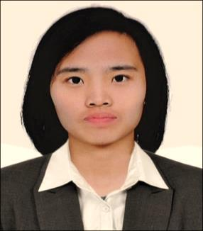
JERAMY, RMT
MEDICAL LABORATORY TECHNOLOGIST
jeramy.380405@2freemail.com

CARREER OBJECTIVE
To enhance my professional skills as a laboratory clinician through knowledge and experience, that I may be able to provide accurate and reliable results therefore, rendering a quality health care service.

EMPLOYMENT
Meycauayan Doctors Hospital and Medical Center, Inc.
Medical Technologist (Generalist)
November 9, 2015 – November 16, 2017

Job Description
- Able to perform and handle all sections when there is lack of manpower
- Performs all the tests in the sections
- Update Histopathology/Pap smear results
- Record and release the results accurately and within the required period of time
- Maintain orderliness, safety and proper work flow in the working area
- Checks on the performance of all equipment in the section
- perform regular preventive maintenance checks
- daily care and cleaning
- report malfunctions, contact and follow-up service crew
- Shall initially handle problems arising in the section and refer them to supervisor as deemed necessary
- Rotate in reception area/warding
- Rotate in night shift
- Rotate in Satellite laboratory
- Shall report directly to the Section Head/Senior Medical Technologist

ACCOMPLISHMENT
Medical Laboratory Technologist - Eligibility Letter Holder
Dubai Health Authority
Dubai, UAE
Reference number: DHA/LS/1012018/778081

Medical Technology Licensure Examination
Professional Regulation Commission (September 2015)
Registration number: 0071092

TRAININGS AND SEMINARS ATTENDED
Medical Technology Internship Training
Veterans Memorial Medical Center
April 1, 2014- January 31, 2015

Certificate of Phlebotomy
Veterans Memorial Medical Center
April 1, 2014- January 31, 2015

Needle Prick Injury and Phlebotomy Seminar
Veterans Memorial Medical Center
June 24, 2014

51st PAMET Annual Convention
“Redefining the Profession, Reshaping the Future”
Manila Hotel, Philippines
December 1-3, 2015

Basic Infection Prevention and Control Seminar
for Hospital Staff and Healthcare Provider
Marymount Professional Colleges
March 30, 2016

HIV & AIDS 101 Orientation in the Health Care Setting:
Initiating the Action through Basic Health Care Provision
Marymount Professional Colleges
October 25, 2016

EasyNAT TB Testing Kit & Dry Bath Incubator Training Seminar
Meycauayan Doctors Hospital, Meycauayan, Bulacan
December 7, 2016

EDUCATIONAL BACKGROUND
Bachelor of Science in Medical Technology
Manila Central University
June 2011- March 2015
Graduate

Secondary
Jesus Is Lord Colleges Foundation, Inc.
101 Bunlo, Bocaue, Bulacan
2007-2011
Graduate

PERSONAL INFORMATION
Nationality : Filipino
Birthdate : November 18, 1994
Age : 23 y/o
Civil Status : Single

