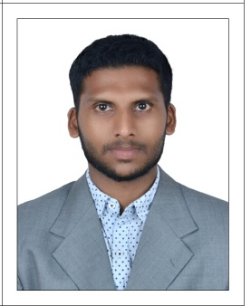
IMRAN

Email Id : imran.380422@2freemail.com

CAREER OBJECTIVES:-

To be part of a growing industry with challenging work environment, offering a chance to excel in personal and team work achievement.

ACADEMIC QUALIFICATION:-
DISCIPLINE | NAME OF  INSTITUTION | BOARD/  UNIVERSITY | YEAR OF PASSING | AGGREGATE
B.E  [Mechanical  engineering] | Karpagam University, Coimbatore | Karpagam University (Sec 3 UGC Act.1956) | 2011-2015 | 6.8  CGPA
XI I Standard | T.M.H.N.U.M.H.S.S | STATE BOARD | 2011 | 63%
X Standard | T.M.H.N.U.M.H.S.S | MATRIC | 2009 | 69.6%

WORK EXPERIENCE
Data Analyst – (HCL Technologies , Sholinganallur , Chennai- 119. From June 2015 to March 2018)
- Information migration to respective project workspaces in EDMS.
- Provide quality assurance of imported data, working with quality assurance analyst if necessary.
- Quality Checking of MEP documents and drawings from vendors.
- Commissioning and decommissioning of data sets.
- Generating reports from single or multiple systems.
- Evaluating changes and updates to source production systems.
- Managing and designing the reporting environment, including data sources, security, and metadata
- Managing master data, including creation, updates, and deletion.
- Coordination with multiple disciplines for upgrades and maintenance of engineering drawings and documents with vendors
- Supporting the document flow for review of Facilities Management.
- Monitor and audit data quality.
- Provide all level technical support for the Design Team from vendor side.
- To Store the Drawing and other cost details into the Cloud Storage Software such as Asite, PM Web tool and Livelink for future analysis.

- Prepared records of all engineering documents, their specification and planned the schedule for the same.

- Answered all queries of the internal and external customers and ensured their satisfaction.

.COMPUTER PROFICIENCY:-

Tools : MS Office package, Power point, AutoCAD, Vision inspection system(rapid 4.0).

PROJECT:-
Minor | Anti-theft locking system for two wheelers
Duration/Team Size | 3 months/ 4 member
Role | Modifier
Environment | safety development in two wheelers

Major | Investigation Of Microstructure And Tool Wear In Cryogenic Treated Tungsten Carbide Insert On Machining Cast Iron
Duration/Team Size | 6 months/ 5 member
Role | Developer
Environment | To improve hardness of carbide tools

PERSONAL INFORMATION:-
Nationality : Indian
Visa Ends : 26-Jun-2018
Date of birth : 15-Jun-1992.
Languages Known : English, Tamil, Malayalam, Arabic(R/W)
DECLARATION:-
I hereby declare that the information furnished above is true to the best of my knowledge and belief.

