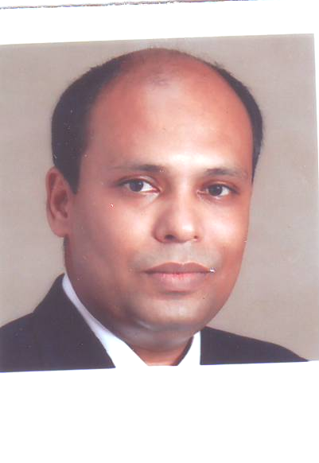

RESUME

……….…………………….

KAUSHIK

KAUSHIK.380424@2freemail.com

Mobile: Whatsapp +971504753686 / +919979971283

OBJECTIVE
To excel in whatever project I undertake and grow with the organization. Presently I am looking forward to a better prospect, career growth and development. In the future I see myself as a successful contributor striving to attain commitment to excellence and ensuring a promising career ahead and through perseverance to reach the top.

SKILLS & COMPETENCIES
Implementation of principles of personalized guest service.
Maintenance of effective database and attaining benchmark.
Handling situations and undertaking new challenges.

Area of interest : Food and Beverage Service

JOB EXPERIENCE
- 02nd June 2014 At Monotel Kolkata working as Senior Outlets Manager.
(luxury business hotel with 109 rooms with 4 f&b outlets)
- 01st February 2012 – 11th April 2014 At HHI Kolkata, worked as Asst Manager Banquet.
(located heart of the city with 7 f&b outlets, 121 rooms & 19,700 sqrft banquet.)
- 20th Dec ’04 – 03Nov 11 : At The Hyatt Regency, Kolkata as Team Leader.
(235 rooms with 6 f&b outlets including 2 specialty outlets.)
- 1st May ‘04 – 15th Dec’04 : Worked in Quality Inn Golden Park Trainee Senior Captain.
(located heart of the city with 84 rooms,3 f&b outlets & extensive banqueting.)
- 24th Sept’01 – 20th Apr’04 : Worked in Majestic Park Plaza Ludhiana as Steward.
(One & only 5 star hotel with 154 rooms, 8 f&b outlets.)
- 4th Sept’2000–16th Sept’01 : Worked in Hotel Swosti Plaza as Senior Steward.
(122 rooms with 6 f&b outlets including 2 specialty restaurants & largest pillarless banquets in eastern india, )

ACADEMIC QUALIFICATION

- Passed West Bengal Board Of Secondary Education In the year of 1992.
- Passed West Bengal Council Of Higher Secondary Education In the year of 1994.
- Completed Bachelor Of Arts ( B.A) From Calcutta University In the year of 1996.

PROFESSIONAL QUALIFICATION

- 3-years full time Diploma in Hotel Management, Catering and Food Science From NIPS Salt lake, Kolkata.

TRAINING EXPERIENCE
- Undergone Industrial Training from HOTEL HINDUSTAN INTERNATIONAL (HHI), Varanasi 1st Oct’ 1998 to 28th Feb’ 1999.

JOB PROFILE
- Attaining quality standards for products and services.
- Maintaining healthy guest relations.
- Anticipating, identifying and meeting guest expectations.
- Delivering a surprise and delight package to guests.
- Acquisition of data and data analysis.
- Maintaining profitability with minimum cost.
- Meeting the forecasted target of annual budget.
- Maintaining the standard service sequence.
- Strict adherence to brand standards and policies.
- Ensuring consistency in terms of food presentation and execution of service.
- Maximum utilization of the available resources.
- Displaying highest levels of motivation to achieve results.
- Conducting training session for the team.

RESPONSIBILITES

- Provide smooth and efficient service at all the outlets, ensuring that the standards are meet at all points of time.
- Fully conversant with all aspects of Micros,IDS and Property Management Computer System.
- Ensure all food and beverage items, equipments and other facilities in the outlets are maintained according to the Departmental Operational manual requirements.
- Constantly strive to satisfy all guests that patronize the Outlet.
- Up sell the menu and induce guests to take slightly higher than medium prices items.
- Maintain par stocks of all equipments and guest supplies.
- Prepare weekly roaster for the team.
- Set up as per guest choice for corporate, social & meeting.
- Handle reservations and blocks halls accordingly.
- Compute bill according to items consumed by guests.
- Record amounts received and prepares reports of transactions.
- Make daily transaction on shift.
- Verify all credit cards presented by guest for validity of the card.
- Prepare Daily Revenue Report.
- Prepare comments card evaluation weekly & monthly.
- Prepare casual requisition according to functions of the day.
- Strictly adhere to all policies and procedures issued by the finance with regards to cashiering and cash handling.
- Report and explain any discrepancies in outlet checks, daily transactions and reports.
- Work closely with the other departments of the hotel, to ensure a smooth operation and personal relation. Deliver F&B service in accordance with departmental standards and procedures.
- Interacts with guests in each of the outlets to solicit comments.
- Communicates with F&B management any difficulties, guest comments and other
relevant information.
- Demonstrates the Service Excellence Basics and ensure the whole of the Outlet
team continually follows the same.
- To rotate and schedule all colleagues in order to provide full coverage for efficient
service and to maximize productivity.
- To recover guest complaints, take remedial action immediately.
- To ensure that all guests are greeted and seated courteously without delay at a properly
- set and clean table.
- To ensure that all guests are served promptly.
- Check on guest satisfaction by talking to the them. .
- To exercise control measures to cut down of chinaware and glassware breakage.
- To be responsible for a daily report in the form of a log book compiled for all shifts.
Obtains all information available for upcoming year (occupancy, forecast, trends,
- reservations, festive periods, etc.)
Keeps updated with new products in the market.
- Provides performance evaluations regarding probation periods, annual
performance reviews, promotion or transfer consideration and salary reviews.
- Regularly solicits feedback from supervisors on colleague performance as well as making
- personal observations.
- Establishes comprehensive training programmes for the Restaurant.
- Evaluates departmental training sessions.
- Personally conducts training for all Outlet colleagues.
- Attends all hotel trainings as required.
- Adheres to all HR and Hotel policies and procedures.
- Continually strives to improve self knowledge and skills.
- Conduct briefing day to day operational.
- Conduct monthly communication meeting with all the f&b staff.
- Work as Manager On Duty at least twice a month.

ASSIGNMENTS DONE ON

- Completed guest Satisfaction.
- Completed Hyatt Earth Course In Environmental Leadership
- Worked in GUCHHI The Indian Specialty Restaurant.
- Worked in 24 hours Coffee Shop.
- Worked in 24 hours In Room Dinning.
- Worked in The Bar.
- Worked at Banquet.

COMPUTER LITERACY

Working knowledge of all contemporary packages.

PERSONAL DETAILS

Kolkata - 700042
West Bengal
India

Nationality : Indian
Marital status : Married
Sex : Male
Height : 5` 6``
Date of birth : 31-03-1975
Languages known : English, Hindi, Bengali.
Hobbies : Listening music.
Present position : Senior Outlets Manager.

DECLARATION

I hereby declare that the above mentioned particulars are true to best of my knowledge and belief.

