rahaf  rahaf.380445@2freemail.com | 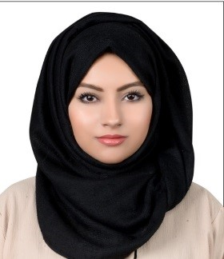

Objective
Ambitious newly qualified Dentist with excellent organizational and interpersonal skills, keen to secure a position with a dynamic and progressive dental practice. Ideal candidate for position requiring drive, responsibility, initiative and challenge.

higlights
DHA Eligibility letter available

Education

Dental Surgeon | RAK College of Dental Sciences

October 2016
Graduated with Bachelors of Dental surgery (BDS)
Awarded with Sheikh Hamdan bin Rashed Al Maktoum award for Medical Sciences for Innovation of the (FULL MOUTH TOOTHBRUSH).

Experience

Junior instructor – Dentist | RAK College of Dental Sciences

September 2017 – Current
Doing multiple procedures at the RAKCODS Dental Centre.
Assisting Professors in Pre-clinical labs.

Dentist – internship | RAK College of Dental Sciences

SEPTEMber 2016 – september 2017
Assigned quota of clinical requirements to be completed over one-year period that included all aspects of Restorative dentistry, Pediatrics, Prosthodontics, Oral surgery, Endodontics and Periodontics.
Performed around 120 fillings which included Composite, amalgam and root fillings
60 simple extractions
Assisted in around 10 surgeries like impacted tooth extractions, apicectomy, alveoloplasty and crown lengthening.
Around 10 post and core (fiber post and amalgam) - 7 posterior crowns and 4 anterior crowns
Assisted in 5 complete dentures and over denture.
Observed few cases of tissue conditioning for removable dentures
5 posterior fixed partial dentures

Skills
- Natural Leader  - Proactive and resourceful  - Bleaching and whitening technique  - restorations | - Pediatrics and prophylaxis expertise  - skilled in root canals  - Diagnostic aids

Activities
Use this section to highlight your relevant passions, activities, and how you like to give back. It’s good to include Leadership and volunteer experience here. Or show off important extras like publications, certifications, languages and more.

Languages
- Arabic ( Mother tongue)
- English ( Fluent)
- Russian (Basic)
- Spanish (Basic)

Personal information
- Jordanian
- Single
- Born 3rd of June 1993
- With Valid Driving license

References are available upon request

