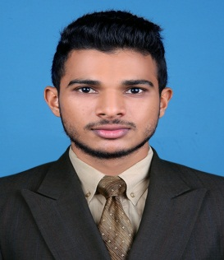  MUHAMMED  Safety Officer  Contact Details:  Email: muhammed.380493@2freemail.com  Mobile: Whatsapp +971504753686 / +919979971283  Personal Details  Date of Birth : 10th Oct 1993  Age : 24  Gender : Male  Nationality : Indian  Religion : Islam  LANGUAGES KNOWN:  To Speak:  English & Malayalam.  To Read and Write:  English, Hindi, Malayalam, Arabic.  PASSPORT DETAILS  Date of Issue: 10thDec 2015  Date of Expiry: 09th Dec 2025 | cAREER OBJECTIVE  To seek a challenging position in where I can utilize my skill experience to the optimum and a part of team that dynamically works towards the growth of the organization and enrich professional skill.  PROFEssiONAL QUALIFICATION  - NEBOSH International General Certificate  IGC I  GC II  GC III  - IOSH Managing Safety(UK)  - Industrial Safety Diploma  AREAS OF EXPERTISE  - Permit to Work, Environment Safety,  - Personnel Protective Equipment  - Scaffolding, Work at height  ACADAMIC PROFILE  - Graduation in B.com (Course Completed)  University of Calicut  - Plus, Two (Higher Secondary Education)  Ansar Junior College – class of 2010  - 10th From Central Board of Secondary Education  Vidyaprakash Public School – class of 2008  ADDITIONAL QUALIFICATION  - First Aid Training Program from RED CROSS, Calicut
PROFESSIONAL EXPERIENCE

- Pee Kay Steel Castings Pvt Ltd
Calicut, Kerala

Role: Safety Trainee
Period:27th March 2017 ~ 31st July 2017
(Four Months)

Duties & Responsibilities:
- To Carry Out Safety Induction for Workers and Visitors in Site.
- Monitoring Work Site Activities and PPE.
- Suggest and Try to Eliminate Unsafe Acts and Unsafe Condition.
- Inspection of Permit Work System.
- Inspect the Welfare Facilities of Employees.
- Accident/Incident Reports Submission.
- Monitoring and Maintain Good Housekeeping Practices on Site.
PERSONAL SKILLS

- Energetic, dynamic & sincere person with outstanding skills.
- Goal oriented, Problem solving, dependable, and flexible.
- Valuable knowledge of monitor and maintain inventory.

DECLARATION

I hereby declare that the above furnished information is true and Correct to the best of my knowledge and belief. If I am selected, I will discharge my duties for the well-being of the entire organization.

Yours Faithfully,
MUHAMMED

