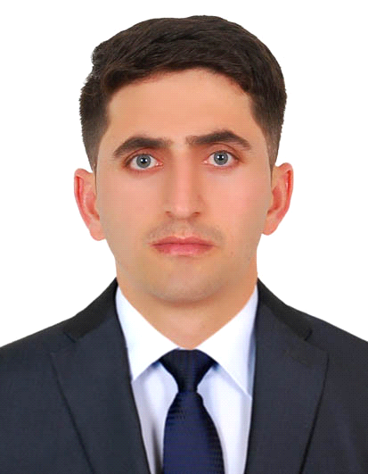
Asif Naveed,
Email: asif.380499@2freemail.com
Mobile: Whatsapp +971504753686 / +919979971283

Objective

To make a friendly environment and have the ability to make as individual and also with team and aim of providing best service.
- SKILLS
- Professional demeanor
- Excellent math skills
- Exceptional customer service
- Fluent in English, Urdu, Hindi
- Opening and closing duties
- Strong communication skills
- Excellent memory
- Quick learner
- Self motivated
- Expertise in invoice and payment transactions
Experience
- Worked as a barista/sales assistant in butlers chocolate cafe at Jinnah International Airport branch Karachi from 2013 to 2016.

- Made and served café baverages with speed, quality and consistency.
- Advised customers on whole bean and bulk tea purchases, detailing origin, flavor and pairing recommendations.
- Maintained and operated espresso machines, blenders, commercial coffee brewers, coffee pots and other equipment.
- Prioritized drink requests while managing interruptions.
- Cleaned counters, machines, utensils and seating areas daily.
- Conducted successful cash audits at the end of each shift.
- Educated coworkers and customers about new products.
- Controlled line and crowd with quick, efficient service.
- Maintained regular and consistent attendance and punctuality.
- Assisted staff in building their expertise of coffees, teas and merchandise.
- Used signage and verbal communication to encourage recycling and composting.

- Working as a restaurant supervisor in DLB restaurant at Dubai Airport Terminal 3 from 2nd April 2o16 to now,

- Greet, assist and direct guest customers, visitors and the general public
- To greet valued clients within restaurant premises and ensure delivery of standard and quality customer service
- Provide information about products and services
- Listen to customers’ concerns, and provide answers or responses
- Take orders, calculate charges, and process billing as cash and payments
- Handle complaints of customers and guests
- Generate sales leads
- Handle cashier work
- Guideline to all waiters and help them any time they need
- Identify and assess customers’ needs to achieve satisfaction
- Build sustainable relationships of trust through open and interactive communication
- Provide accurate, valid and complete information by using the right methods/tools
- Answer all incoming calls and handle caller’s inquiries whenever possible
- Familiarity with POSIFLEX systems as cash and practices

Worked as a waiter in P C hotel Karachi 2008-2013
- Have a good experience of banquet events setups of different shapes like I, U,T shape, Round shape classroom style Theater shape Dinner, Brunch, Breakfast service and setup in Pearl Continental Hotel Karachi,
- Controlled line and crowd with quick, efficient service.

- Education,

- 2015 Bachelor of Arts: B.A University of Karachi Karachi.

- 2013 Associate of Arts: I.com Karachi Board Karachi .

- 2005 High School from (F.B.I.S.E), Islamabad board.
- Attended a Treating Program on Search and Rescue, Fire Fighting and First Aid
- Certificate of Merit from W.S.P.A. (world society for the protection of animals.)
- Computer Skills
Have a good command on internet browsing
Have a strong knowledge of hardware and software
MS Office
Windows 98, 2000, XP, Vista

