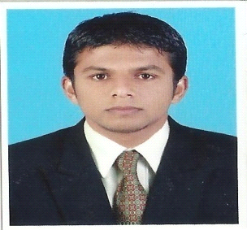

UBAIS Email:-ubais.380500@2freemail.com
whatsapp +971504753686 / +919979971283
Accountant
Mainly Accountant with more than four year experience in the business. Involved sales,managing and administrate of business.Also interested work in sales,Administrate,supervising,merchandising and financing.

SKILLS

Peachtree
Quickbook
Ms word-Arabic
Tally.Erp9
Ms Office

C,C++
Cashier
Sales
HTML
Asp.Net
Sql Server

WORK EXPERIENCE
Galaxy City Supermarket Well Mart Retails Hyper market
Accountant and cashier Accountant and Cashier
Sharjah ,UAE 2015-2017 Kochi,India 2012-2015
- Financial Reporting, Banking, Purchase, Sales.
- Supervised Accounts Payable, Accounts Receivable, Order Processing, and Benefits.
- Managed Cash Details.
- Prepared all monthly, quarterly and annual financial report.
- Managing staffing Salaries.
- Financial reporting, Daily cash management and relationships with Vendors.
- Daily invoice entering the computer and checking cost and sales price.
- Tallying cash in hand at the end of the day shift and planning for cash bank deposit with next day purchase.
- Made entries of daily business transactions in book of account.
- Daily sales and Purchase
- Supervised Accounts Payable, Accounts Receivable, Order Processing, and Benefits.
- Managed Cash Details.
- Prepared all monthly, quarterly and annual financial report.
- Managing staffing Salaries.
- Financial reporting, Daily cash management and relationships with Vendors
- Buisiness developing and Advicing.

EDUCATION
Bachelor of Commerce B.COM Sikkim university,India 2011
Bachelor of Computer Application BCA Mangalore university,India 2011

PASSPORT DETAILS
D.O.B 17/02/1990

Place of issue Kozhikode
Date of issue 30/08/2011
Date of Expiry 29/08/2021

Language: English,Malayalam,Hindi,Arabic read&write

DATE: UBAIS
PLACE:

