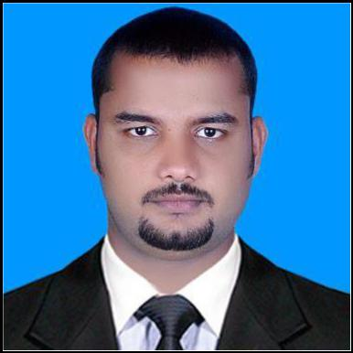
CURRICULAM VITAE

RIYAS

DUBAI - UAE

E-mail: riyas.380514@2freemail.com
Mobile: Whatsapp +971504753686 / +919979971283

Objective

To pursue a career in Sales and Accounts with a reputed organization where my education and experience can have valuable application. To achieve a challenge in demanding & progressive growth-oriented position in a fast-growing organization where my abilities, knowledge & experience can be fully utilized.

Professional Summary

- 6 years of professional experience in Sales and accounts in India & KSA

- Hold a bachelor’s degree in commerce

- Proficient in English, Hindi, Arabic (Basic) and Malayalam

- Prepare financial statements includes balance sheet and P&L a/c.

Educational Background

- Bachelor of Commerce (B. Com) from Calicut University, Kerala, India. (2004 to 2007).

- Plus Two from Board of Higher Secondary of Kerala.

WORK EXPERIENCE

1. COMPANY: AL MUTHERI SPARE PARTS, RIYAD-KSA

DESIGNATION: Salesman cum Account Assistant

PERIOD: March 2013-Nov 2015

JOB PROFILE: The job profile involves attending walk-in customers, give information about the products, know about the customer needs and provide them. Make sure the customer is satisfied with item sold

- 1 -

Job Description:

  - Arranging proper displays in Showroom.

  - Timely Ordering Goods from warehouse

  - Assisting customer with product information

  - Maintain proper inventory controls, facilitated inventory transactions

  - Maintenance the stocks and timely book keeping records: journals, general ledger, receipt and Payments

- COMPANY: RAHMA Building Materials. JEDDAH - KSA

DESIGNATION: Sales cum Office Admin

PERIOD: Nov 2015 -Dec 2017

JOB PROFILE: The job profile involves attending customers, follow-ups and arranging deliveries. Also look around the office duties as well

COMPUTER AWARENESS

- Well versed with MS Office, TALLY (7.2 & 9. ERP), PEACH TREE Etc.

 | PERSONAL PROFILE
Date Of Birth |  |  |  | 31th May 1985
Marital Status |  |  |  | Married
Nationality |  |  |  | Indian
Father’s Name |  |  |  | Ali Hassan
 | Passport Details:
Place of Issue |  |  |  | : Malappuram
Date of Issue |  |  |  | : 02/05/2017
Date of Expiry |  |  |  | : 01/05/2027
Visa Status |  |  |  | : Visit Visa

Declaration

I hereby declare that the above-mentioned information in the resume are true and correct to the best of my knowledge and belief.

- 2 -

