ANKITA
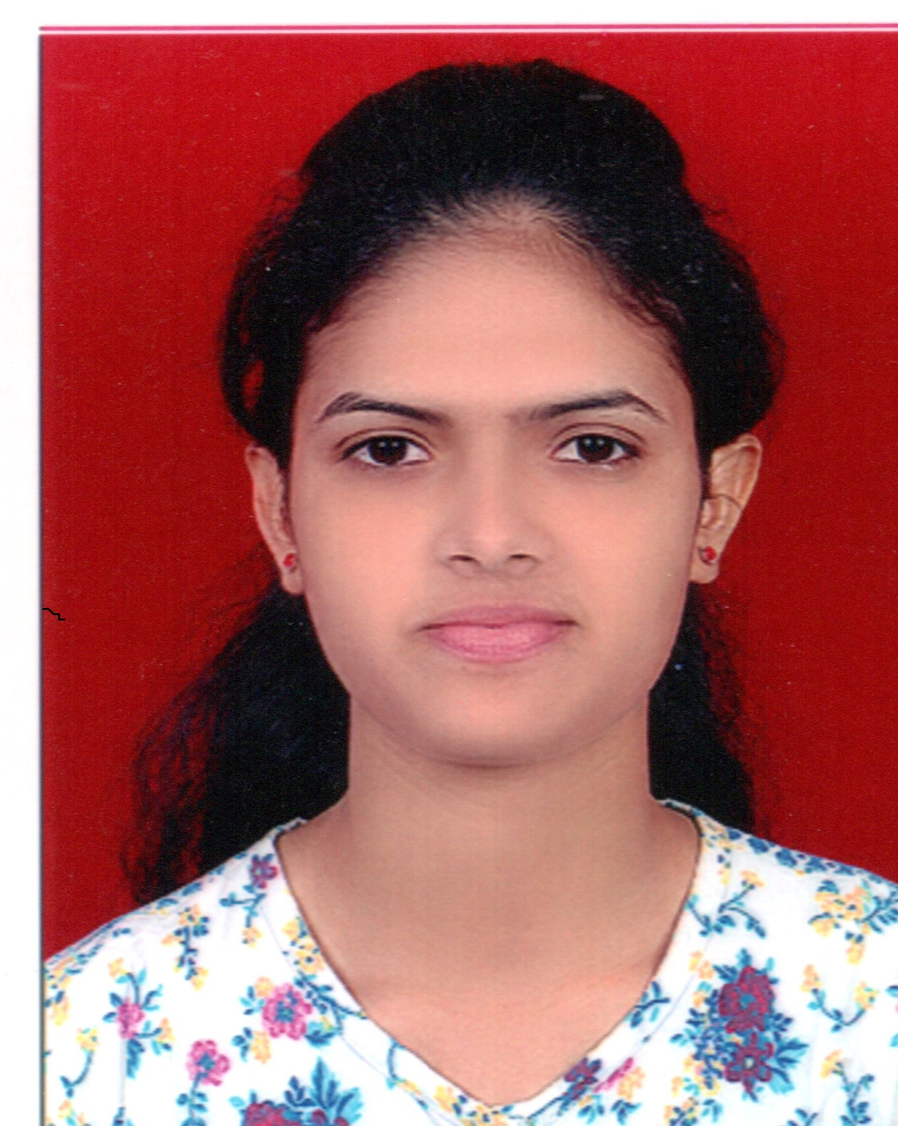
B.E. Mechanical

Email Id: ankita.380562@2freemail.com
Mobile: Whatsapp +971504753686 / +919979971283

OBJECTIVE:

Seeking a dynamic and challenging position, that can invigorate and enrich my skills to work with a progressive organization where I can utilize my knowledge and ability to provide high quality services.

PROFESSIONAL EXPERIENCE:

- PAWANPUTRA ENGINEERS PVT. LTD-ANDHERI

Designation : SERVICE ENGINEER
Department: Service dept.
Duration : August.2017 To January.2018

- JSW Steel Coated Product Ltd. -Tarapur

Designation : TRAINEE ENGINEER
Department : Mechanical Maintenance Dept. in JSW Captive Power Plant
Duration : From Aug. 2015 to Aug.2016
Job Profile : Monitoring & Reviewing the operation of
plant equipment’s and minimize MTTR (Mean Time To Repair) &
maximize MTBF (Mean Time Between Failures) of machines.

Roles:
- Planning and implementation of Goals and Objectives for the Mechanical Maintenance Department.
- Monitoring & reviewing the operation of plant equipment’s and systems constantly to minimize unplanned downtime, improving MTBF and reducing MTTR.
- Effective Spare Management.

Responsibilities:

- Planned/Unplanned maintenance of :
- Boiler, Economiser, APH, ESP.
- Coal Crusher, Belt Conveyer.
- PA, FD, ID Fans.
- Wheel loader.
- Material lifting cranes.

Planning and Management:

- Manage departmental activities.
- Work execution as per SOP (Standard Operating Procedure).
- Planning & execution of preventive maintenance of machines as well as corrective maintenance of machines.
- Keep updates of Daily breakdown reports.
- Reporting to senior staff regarding daily work progress, difficulties to achieve target
- Using ERP Software: SAP for “maintaining Log book, Daily Checklist of Equipment, Material Requisition and Material Indent”.

SUMMER TRAINING:
- Reliance Infrastructure ltd., Dahanu Thermal Power Plant

PROFESSIONAL QUALIFICATION:

- Good command over Ansys 14.5
- Descent knowledge of Pro- E wildfire 4.0
- Proficient with the use of windows, PowerPoint, MS OFFICE and the internet
- Basic knowledge of SAP module

ACADEMIC PROJECT:

- Project Name : “Waste Plastic Fuel”
Sponsored By : Reliance Thermal Power Station , Dahanu
Description : In which we designed the system and prepared diesel out of waste
Plastic using pyrolysis process.

EDUCATIONAL QUALIFICATION:
Exam | University/Board | Year of Passing | Percentage
B.E.(Mechanical Engineering) | Pune University | 2015 | 71.60%
HSC | Mumbai Board | 2011 | 68.83%
SSC | Mumbai Board | 2009 | 80.30%

PERSONAL SKILL:
- Problem solving
- Hard working & responsible
- Ability to handle multiple tasks.

PERSONAL HOBBIES:
- Gardening
- Games/Sports
- Music/playing drums
- Event Managing

PERSONAL DETAILS:
Date of Birth : 31 Dec 1992..
Nationality : Indian
Marital Status : Single
Language Known : English, Marathi, Hindi
Visa Details : Visit visa-valid until-26 July 2018

I hereby declare that all the details furnished here are true to the best of my knowledge.

Yours Sincerely

(Ankita)

