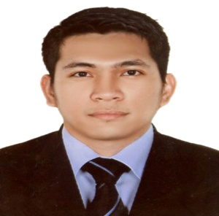
RUBEN
Email Add: ruben.380572@2freemail.com
Mobile: Whatsapp +971504753686 / +919979971283
Qualification: BARISTA/ WAITER

CAREER OBJECTIVES
I am seeking career a career- oriented placement, which would allow for increasing levels of responsibilities, to grow professionally, to be a part of a highly competitive company, and to be given a chance. or opportunity to a qualified position with efficiency and potential for advancement.
EDUCATIONAL ATTAINMENT
COMMERCIAL COOKING NCII/ CULINARY ARTS SECONDARY GRADUATE
Vocational/ Technical School (TESDA PHILIPPINES) CEBU INSTITUTE OF TECHNOLOGY
July 03, 2008-September 23, 2008 March 8, 2003

WORK EXPERIENCE
Company: FALLA FOODS AND JUICES (AMERICAN/ ITALIAN RESTAURANT)
Position : JUICE MAKER (July2016- November 2017)
Job description:
- Maintain cleanliness and sanitized working area
- Preparing new variety of mocktails, and making new recipes of cold drinks
- Maintain bar checklist of opening and closing shift
- Prepare inventory of bar items, knowledge in FIFO and FEFO
Company: COPPA CAFÉ, MUSCAT OMAN (FRENCH/ITALIAN COFFEE SHOP)
Position : BARISTA/ BURGER AND SANDWICH MAKER ( April 05 2015-April 05 2016)
Job description:
- Greet the customer with a friendly smile
- Prepare hot and cold beverages with different types
- Maintain cleanliness and prepare burger and sandwiches
- Handling cash report daily and monthly sales
- Prepare opening and closing shift in the shop
Company: WAFI GOURMET DUBAI (LEBANESE RESTAURANT)
Position : BARISTA/JUICE MAKER (October 2009-February 2015)
Job description:
- Prepare and serve coffee such as espresso, fresh juices, fruit platters
- Knowledge in making coffee with latte arts
- Knowledge in making new recipes of mocktail
- Prepare inventory daily and monthly, in the bar items
- Provide customer with product details, such as coffee blend or preparations description
SKILLS
- Have strong customer oriented skills
- Knowledge in basic computer
- Knowledge in cashiering
- Can work under pressure and less supervision
- Good in English communication both oral and written
PERSONAL DATA
Date of Birth : June 13 1983
Marital status : Single
Nationality : Filipino
Visa status :Visit Visa
I hereby certify that all above information are true and correct at the best of my knowledge and belief.
RUBEN

