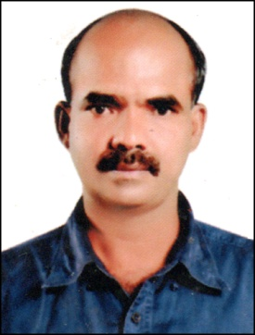
BIO DATA
George
Email: george.380657@2freemail.com

Post Applied for: Welder’s Forman/ Welder 6G TIG & ARC

PERSONAL DETAILS
Date of Birth : 05/05/1966
Nationality : Indian
Marital Status : Married
Religion : Christian
Sex : Male
Languages Known : English, Malayalam, Hindi & Tamil
QUALIFICATION
SSLC
WORK EXPERIENCE
1 year worked as a Welder in Cochin Refinery Ltd.
1 year worked as a Pipe Welder in Deepak Construction
GULF EXPERIENCE
- 7 years worked as a Welder in Abu Dhabi from 02-05-1995 to 27-06-2002
- 1 year worked as a Pipe Am Vessal, TIG & ARG Welder from 08-01-2003 to 08-07-2003
- 2 year worked as a Welder in STS Oman P.D.O
- Ramsis Bahrain as a Welder’s Forman.

DECLARATION

I hereby declare that all the above mentioned details are true and correct to the best of my knowledge

Place : Sooranad GEORGE
Date:

