James  Email Address: james.380697@2freemail.com  Location: Dubai, UAE. | 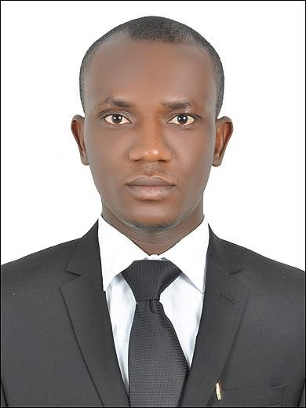

OBJECTIVES:

Seeking a position as a facilities coordinator. Offering exceptional facilities management and claim assistance in a facility management or real estate company to the best of my ability thank you.

- SUMMARY OF QUALIFICATIONS
•Develop and execute guidelines for furnishings campus wide.
- Manage furniture inventory for new purchases, maintenance and repair of existing furniture.
- Develop project estimates for customers, provide cost, schedule and scope information for customer review and approval.
- Prepare monthly occupancy status report to management.
- Maintain and manage physical asset and storage site inventory
.
ACCOMPLISHMENTS
• Ensured owners receive their reimbursement form on time .
• Take all approval before the MEP starts maintenance .
• Send all relevant information to the owners association .
PERFORMANCE PROFILE
Highly enthusiastic, motivated and self-directed insurance professional having strong background in facilities management . Excellent speaking, listening and facilitating skills backed by a deep rooted interest in numeracy. Expertise includes:
• Excellent customer service
• Demonstrated ability to maintain assessment records and site confidentiality

PROFESSIONAL EXPERIENCE
EMRILL LLC. DUBAI, January, 2013 till August 2017
Concierge / facility coordinator ( place community management )
- Assist Facility Management Team with tactical planning for the team’s goals and objectives
- Provide facility specific assistance to the project management team as needed or requested
- Manage and maintain small facility management tasks as assigned
- Coordinate special events in support of client or JLL
- Provide support for meetings and conference room reservations as needed and directed
- Assist with the coordination and scheduling of maintenance activities

Psychiatry and therapy center DHCC (uae)
Insurance Coordinator - September 2017 - February 2018
• Assist patient with eligibility and benefit coverage questions
• Practiced professional telephone etiquette and customer service while making claims
• Coordinates with the insurance company for approval and reinsurance procedures
• Coordinates with clinics for the approved
• Knowledge of insurance protocols for requesting approval

ADDITIONAL STRENGTHS
• CPR and First Aid (BLS)
• Basic knowledge of computer MS office
EDUCATION:

Diploma in dental assistant – Gulf medical university Ajman (uae) (2014 - 2015)
- Certificate in medical insurance billing – Gulf medical university Ajman (uae)

WEST AFRICA SENIOR SCHOOL CERTIFICATE EXAMINATION - Nigeria (2004 - 2010) –Attested

COMPUTER PROFICIENCY
- MS Office, Excel and Outlook.

PERSONAL DETAILS
Date of Birth : April 19, 1991
Nationality : Nigerian
Visa Status : Employment
Marital Status : Single
Language Known : English

