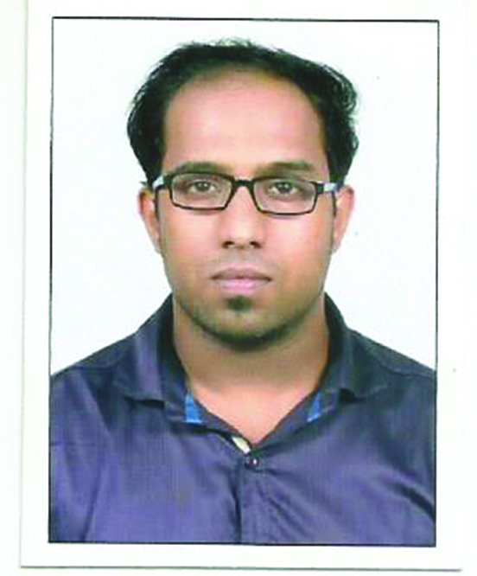
Dr. SHAJI (BDS)
EXPERIENCE: NOV 2015 – DEC 2017
Email ID: shaji.380726@2freemail.com

PROFESSIONAL SUMMARY:
- Dynamic, accomplished &talented dental professional with experience, ensuring high standards of competent care for a wide variety of patients with diverse needs.
CAREER OBJECTIVE:
- Seeking for a General Dentist opportunity to work with a forward thinking and highly regarded dental organization
CAREER HIGHLIGHTS:
- Passed DUBAI HEALTH AUTHORITY dental licensing examination on 26th march 2018.
- As SENIOUR DENTAL HOUSE SURGEON AT GOVT. GENERAL HOSPITAL KOTTAYAM( MAY 2017- DEC 2017)– 7 months
- Worked as General dentist at SAMS DENTAL CLINIC PATHANAPURAM ,KERALA (INDIA) ( 20 NOV 2015 - MAY 2017) -1.6 years
- Passed BDS Degree Examination , Dr. MGR UNIVERSITY , Aug 2014
- 1 year internship at Rajas dental college ,Nagercoil ,India
AREA OF EXPERTISE:
- Root Canal treatment involving majority of posteriors among anteriors ,core build up using Reinforced fibrepost in anteriors and stainless steel post for posteriors
- Fixed orthodontic therapy along with twinblock myofunctional appliance for class 2 skeletal patient retruded mandible
- prosthetic works like Removable partial full dentures, Crown & bridges
- Assisted caldwell luc approach operation for foreign body removal at OT
- Painful carious tooth treated with. Pulpotomy , pulpectomy
- Transalveolar extractions with difficult molars , impaction surgeries like mesioangular and mild distoangular extractions , Alveoplasty for bony irregularities
- Cosmetic smile designing like Laminate Veneer
- Performed incisional& excisional biopsy of oral cavity
- Excellent command over pediatric patient & all pediatric cases including pulpectomy, space maintainers
- Adequate knowledge in TMJ disorder and conservative management using reposition and stabilization splint
Has done number of Fixed Orthodontic cases using MBT prescription including:
- Bimax cases ,
- openbite cases treated by reverse curve NiTi wires
- instanding lateral incisor treated by using NiTi pushcoil spring , overlay wires offset bend on 0.018ss /0.012 niti inverting the bracket of lateral incisor
- Skeletal Malocclusion treated using Functional appliance with Twin-Block and Frankel 2 appliances
CDE’S:
- Interceptive Orthodontics Skeletal or Dental - A Dilemma by Dr. BENOY AMBOOKEN MDS
- Lasers in dentistry a practical Approach by Dr. AJAY KAKAR MDS
COURSES ADD-ON:
- ONE YEAR COURSE ON ‘CLINICAL ORTHODONTIC & DENTOFACIAL ORTHOPEDIC PROGRAMME on March 2016 to 2017
PERSONAL PROFILE ACADEMIC DETAILS
DOB: 29 JULY 1991. RIVER DEE INTERNATIONAL SCHOOL CBSE 2007
GENDER: MALE HIGHER SECONDARY SCHOOL (PLUS TWO), 2009
NATIONALITY: INDIA BACHELOR OF DENTAL SURGERY- NOV 2015
MARTIAL STATUS: SINGLE
LANGUAGE KNOWN: ENGLISH, MALAYALAM, HINDI
TYPE OF JOININIG: IMMEDIATE JOINING

DECLARATION:
- I hereby declare that above statements are true and correct with all my knowledge and also to the help of our lord.

