CURRICULUM VITAE 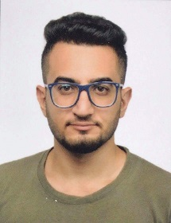
YASEEN
Email: yaseen.380755@2freemail.com

Career Objective
To pursue a challenging career in Pharmacy, providing accurate medication distribution services and offer patients counseling on their medication needs .i will able to utilize my strong organizational skill and ability to work well with people . which will allow me to grow personally and professionally. I am self motivated and able to work both independently and as collaborative team member
Core Competencies
- Excellent in interpersonal communication
- A good team player
- Exposed and experienced in a cross-cultural environment
- A perfect planner, always on or before deadline
- Flexible, act according to the situation
- A creative individual

Professional Experience

Fortis Hospital, Benguluru, India

Translator and Patient Coordinator

- Coordinated with patients from the Middle East
- Quick Leaner/Hard working, detail oriented and able to multi-task
- Strong interpersonal skills
- Work well with others at various levels
- Bridged the language gap of patients with the Medical Authorities by donning the role of a Translator
- Met the medical needs of patients and catered to their health requirements
- Played the role of a negotiator between the physicians and patients

Education

Bachelor’s in pharmacy (Still pursuing), Acharya Nagarjuna University, India, 2014-2018

- Detailed study of Pharmacology, Chemistry and Pharmaceutics
- Analysis of Pharmaceutics
English Diploma, Valuepoint Academy, India, 2013-14
- High School, Almarkazia, Baghdad, 2013

Technical Knowhow
Expertise in using computers, good understanding of software and computer programming

Hobbies
traveler, swimmer, hardcore gaming , brilliant cook, baker,

Personal Details
Nationality : Iraqi
Date of Birth : 2nd March 1995
Gender : Male
Marital Status : Single

