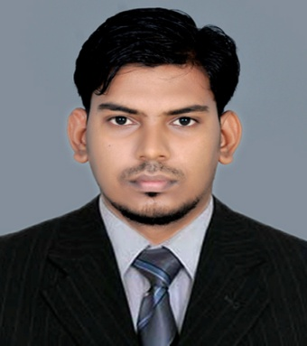 | ASHOK  ELECTRICAL ENGINEER  Ashok.380761@2freemail.com

CAREER PROFILE
- Ambitious electrical engineer who continuously exceeds both company and personal goals.
- Expertise in AutoCAD and Autodesk inventor.
- To achieve professional excellence and develop leadership qualities.
- Achieving the company goals and move up in the organization hierarchy.
- Looking for responsible and challenging career, where my skills can be effectively utilized and contributed for organization success
- Having work experience in Electrical Project & Maintenance.
- Good understanding of Electrical Drawings, Planning of Projects, Erection & Maintenance.
- Both practical as well as theoretical knowledge of Different Electrical Equipments.

TECHNICAL QUALIFICATIONS
- Ability to take own initiative and motivation to learn new technologies.
- Certified in AUTOCAD level 1 2D by CADD Center.
- To achieve professional excellence and develop leadership qualities.
- Good knowledge of Engineering Fundamentals & Electrical Equipments.

WORK EXPERIENCE

BR. ELECTRICAL ENGINEERING WORKS, Bangalore  05/2014 – 05/2015 | - Install, demonstrate, troubleshoot and maintain various switchgear equipment’s.  - Erecting and commissioning of transformers, generators and distribution panel boards.  - Engaged in responsible activities such as work planning, scheduling, coordinating and iso documentation & supervision of electrical wiring works for various equipment’s.
ALUMINIUM INDUSTRIES, SWITCH GEAR DIVISION -MANNAR  06/2015 – 02/2017 | - Supervising all electrical related wiring terminations in 33 kv vacuum circuit breaker for railway projects.  - Coordination in electrical designing of wiring arrangements with design department.  - Maintaining complete log register and daily work reports of workers in electrical department.  - Taking class for new trainee workers for panel termination and related electrical basics.  - Coordination with planning department regularly for achieving maximum production output for every month.  - Coordination with planning department regularly for achieving maximum production output for every month.
ROVE AUTOMATION & INSTALLATION WORKS LLC – DUBAI  PROJECT ENGINEER  Since – may 2017 | - Rendered technical drawings and electrical systems specifications that exceeded company standards.  - Site handling experience in monitoring installation and operations to consistently meet rigorous customer requirements.  - Good working experience in doing auto cad works and drafting electrical diagrams.  - Have a clear knowledge in understanding electrical drawing.  - Have good ideas about home automation, guest room management system, lighting control system and KNX System.

EDUCATION
BACHELOR OF ENGINEERING  2014 | - BACHELOR OF ENGINEERING in ELECTRICAL AND ELECTRONICS ENGINEERING with FIRST CLASS from NARAYANA GURU COLLEGE OF ENGINEERING under ANNA UNIVERSITY, CHENNAI in 2014.
HIGHER SECONDARY  2010 | - HIGHER SECONDARY EDUCATION with FIRST CLASS from NAIR SAMAJAM HIGHER SECONDARY SCHOOL, MANNARI in 2010.  .
HIGH SCHOOL EDUCATION  2008 | - HIGH SCHOOL EDUCATION with DISTINCTION from SREE BHUVANESWERI HIGHER SECONDARY SCHOOL, MANNARI in 2008.  .

COMPUTER PROFICIENCY
- 2D Drafting using AUTOCAD.
- Have user level experience in all Microsoft Office Applications.

DRIVING LISENCE
UAE DRIVING LISENCE | - Holding a valid UAE DRIVING LISENCE (AUTOMATC).
INDIAN DRIVING LISENCE | - Holding a valid INDIAN DRIVING LISENCE (MANUAL).

PERSONAL INFORMATION
GENDER | - | MALE
DATE OF BIRTH | - | 11/10/1991
NATIONALITY | - | INDIAN
DRIVING LISENCE | - | - HOLDING A VALID UAE DRIVING LISENCE  - HOLDING A VALID INDIAN DRIVING LISENCE
LANGUAGES | - | ENGLISH, MALAYALAM, HINDI,TAMIL
CURRENT VISA STATUS | - | JOB VISA (GENERAL ELECTRICAL ENGINEER)

