Personnal details | DAHMANI
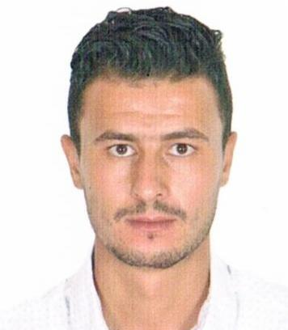
 | Dahmani.380796@2freemail.com
 | Sex Mal| Date of birth30/10/1989 | NationalityAlgerian
OBJECTIVE A challenging position in a company which I can use my skills with the possibility of promotion
and work with a good teamwork.
Occupation wanted Civil Engineer with excellent Structural background.
Job FIELD Construction / Consulting / Technical / Sales

Professional experiences

09/10/2016–present | Site engineer
 | SARL AL BAYRAK, Ain Temouchent (Algeria)
Realizationof 1000 AADL lodging (RUS-external arrangement)

- Assist resolving issues raised by contractors (eg. Requirements for time extensions, change order requests, variations etc) , make recommendations.

- Review related items within the contractor’s construction schedule (CCS) in coordination with the Planning Engineer (eg. Shop drawing submittal log, procurement schedule and material submittal log etc ) prior to its approval by the office

- Ensure that all materials delivered on site are being adequately stored and protected as per manufacturer’s recommendations in order to avoid damage for materials

14/05/2016–01/08/2016 | Site engineer
 | SARL DEK IN SAN, Oujlida tlemcen (Algeria)
Realizationof 2000 AADL lodging
supervision of project at the level of execution quality with the use of tunnel casing system
 | Type or sector of activity Construction

21/12/2014–14/05/2016 | Structural Engineer
BOUKARABILA Khaeira Consulting Engineers, elkiffan tlemcen (Algeria)

Job responsibilities:
- Check & Review all design calculation and shop drawings for Steel structure design, Concrete design and Earth works.
- Check & review all Structural & civil material submittals sheet (MSS) &mix design for concrete.
- Daily visit for inspection of the work at site as per Approved shop drawings.
- Prepare monthly progress reports.
- Giving the answers for the queries of contractor as per technical drawings. .
- Prepare weekly meeting between the owner and main contractor to discuss & solve project problems.
- Check & review monthly payment certificate of civil and structural works.

 | Type or sector activity Construction

EDUCATION AND FORMATION

2014 | Master 2 in civil engineering, structures engineering
University of ABOUBAKR BELKAID, Tlemcen (Algeria)
end of studies' project: Dynamic analysis of a response of a structure

2012 | licencein civil engineering,structures engineering
 | University of ABOU BAKR BELKAID, Tlemcen (Algeria)

2008 | Baccalaureatelife and natural sciences
 | IkhouanAttarhigh school, Tlemcen (Algeria)

PERsONal competences

Mother tongue | Arabic
Other languages | Understand |  | Speak |  | Write
 | Listen | Read | take a part in a conversation | Oral expression continuously
french | B2 | C1 | B2 | B2 | B2
 | TCF
English | B1 | B2 | B1 | B1 | B1
Level : A1 and A2 :basic user - B1 and B2 : independent user - C1 and C2 : tested user.
Common European reference framework for language.

Organizational/ managerial competences | - Leadership (current responsible for a team of 10 persons )  - A well acquired organization capacitywhile head site (invitation of intervening, conferences promotion)  - Qualifications of the acquired team direction thanks to my experiencein the construction field.

Competences related to occupation | - Accomplish technical calculations (strength of materials, reinforced concrete, RUS).  - Accomplishthe execution plansof detail (casing plan,Reinforcement, purification, DWS, Sewerage systems,lighting ...).  - Masterthe software SAP 2000. Etabs. AutoCAD, MSproject, word andExcel.

Design Experience:
- Many villas & grand residential villas.
- Many small buildings (residential & commercial).
- Mosques.
- Many Schools.
- Many Towers.

License driving B

