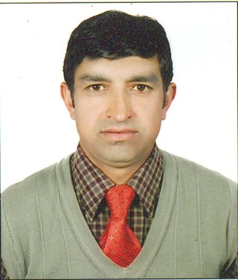
WOKIL

Email: wokil.380803@2freemail.com

OBJECTIVE

Seeking a good career and holding a responsible position in the reputed organization and ensure credible performance to work towards exceeding the set goals contributes for the organization.

KEY SKILLS
- Learn quickly, and able to work under pressure
- Results-oriented, self-starter with experience
- Excellent analytical and communication skills
- Committed to providing excellent quality service.
- Skills in cooking and preparing different recipes
- food handling with best food hygiene and its standard

CARRER SPAN

commi chef
social house(Dubai Mall, Dubai) October 2014-till date

Duties and Responsibilities
- Prepare a variety of meats, seafood, poultry, vegetables and other food items in broilers, ovens, grills, fryers and a variety of other kitchen equipment according to restaurants standardized recipes.
- Attaining of briefing and follow the instructions of chef for the day operation.
- Maintain the food quality according to its instructed recipe.
- Assumes 100% responsibility for quality of products served.
- Knows and complies consistently with our standard portion sizes, cooking methods, quality standards and kitchen rules, policies and procedures.
- Regular duty for food cooking mainting its right temperature and good storage in its proper time.
- Awareness on food hygiene for the healthy food production .
- Maintains a clean and sanitary work station area including tables, shelves, grills, broilers, fryers, pasta cookers, sauté burners, convection oven, flat top range and refrigeration equipment.
- Handles, stores and rotates all products properly.
- According to international cusine working in every sections of the kitchen asian,western.salad pizza and pastry.
- Making of fresh sushi with its good quality and safety.
- Preparing the inventory of food items accordingly every weeks for the easy implementation of food products.
- Consulting with chefs for any food issues for the better quality of food and following theirs orders and instructions.
- Handling the busy operation in any situation for long hours for the great satisfaction of coustmers.

EDUCATION

Parbati Higher Secondary School.Kavreplanchowk,Nepal(1994-1996)
- Higher secondary education board( HSEB)+2 level in Health Education course.

Parbati Higher Secondary School.kavreplanchowk,Nepal 1994
- Passed School Leaving Certificate(SLC).with major subjects education and maths.

ACHIEVMENTS
- Awarded employee of the month certificate for the month of May, 2016.
- Awarded employee of the month certificate for the month of February, 2017.
- Award for highest rating (A+Green audit certificate) given by Dubai Municipality.
CRENDENTIAL
UAE zzDRIVING LICENCE

CRENDENTIAL
UAE DRIVING LICENCE

PERSONAL INFORMATION

TRAINING AND SKILLS
- Basic Course in Computers ( Microsoft Office, Excel, Word, Power-point and web browsing).
- Attained Basic Food Hygiene (BFH) training in Dubai.

Competencies:
- Excellent Communication skill-English, Hindi and Nepali.
- Excellent problem identification ability.
- Positive attitude and atitude to learn.
- Leadership and management ability.
- Excellent listening, presentation, and writing skills.

PERSONAL INFORMATION

Name : Wokil

Date of Birth : 08/03/1979

Nationality : Nepali

Sex : Male

Maritial status : Married

Language known : Nepali English and Hindi
DECLARATION
I hereby declear tht above mentioned information are true and correct to the best of my knowledge and belief.

