CURRICULUM VITAE 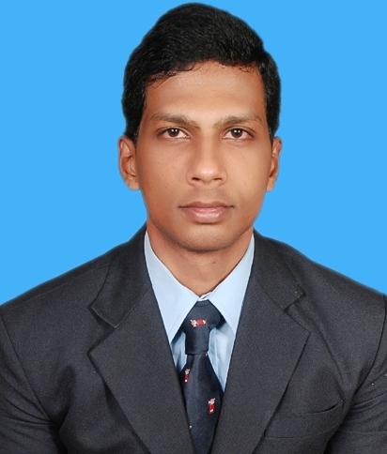

OSMAN
Osman.380807@2freemail.com

CAREER OBJECTIVE
Seeking a challenging career with a distinctive organization, having an operation that provides a motivating work environment, as well as opportunity for career advancement in order to increase, enhance, broaden and properly utilize my qualifications as well as my experience.

PROFESSIONAL OPERATING PLAN
Areas of interest are Accounting Assistant/Finance/Admin/Data Entry, Equipped with required sound Fundamentals

Work Experience
Total year of Experience : 8 Years.

Employment History:
- Company : Sun Slate Works
- Designation : Accounting Assistant
- Duration : 2016 to 2018

- Company : Al khareef Commercial Enterprises (Oman)
- Designation : Accountant
- Duration : 2015 to 2016

- Company :Zaki & Associates
- Designation : Accounting Assistant
- Duration : 2013 to2015

- Company :Stafford luggage& Leather Lounge
- Designation : Accounting Assistant
- Duration : 2010 to 2013
Responsibilities
- Preparing all payments and received voucher
- Preparing invoice and quotation
- Preparing payment of cheques
- Maintaining petty cash and expenses
- Working directly in coordination with Chief Accountant
- Maintaining all office filling.
- Maintaining Data Entering activities

Educational Qualification
P.G Completed M.B.A in Finance from Osmania University, Hyderabad, telangana.
Graduation Completed B.Com Computer’s (Bachelor of Commerce)
From Osmania University, Hyderabad, AP. India.
Intermediate Completed from Board of Intermediate Education Govt.Of A.P. India.

S.S.C Completed from Board of Secondary Education, Govt. of Andhra Pradesh, India.

Technical Qualification: -

- Diploma in Accounting Packages.
- Diploma in Computer Hardware & Applications.

Computer Skills: -

Operating Systems : MS- Windows 98, 2007, Windows XP, Windows 7.
Application Software : MS – Word, MS – Excel, MS – PowerPoint.
Accounting Packages : Tally Erp 9.

Personal information:
Date of Birth : 06 / 09 /1989
Marital status : Single
Nationality : Indian
Languages : English, Urdu, Arabic, Hindi

