AREAS OF EXPERTISE

General Administration
Secretarial Works
Hospital Admin assistant
Public Relations
Customer Relations
Event organizing
Personal Assistant

PROFESSIONAL

*Government Diploma in
Computer Hardware
Engineering.

*Bachelor Degree

PERSONAL SKILLS

Multilingual
Organizer & Good team player
Training &Teaching
Excellent Interpersonal skill
Positive attitude & Behavior
Time management
Responsible & Adaptable
Learn continuously

PERSONAL DETAILS

Nationality : Indian
Visa Type : Visit

YAHYA
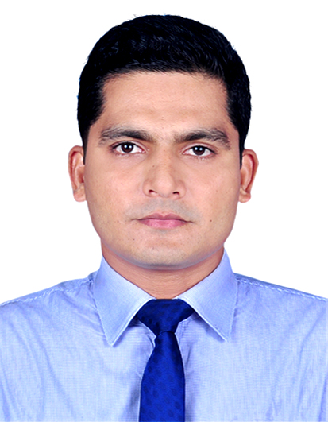
E- mail: yahya.380812@2freemail.com

PERSONALSUMMARY

To build an excellent career in UAE where I can prove my caliber and gain good experience. An English Literature Graduate and a Computer Hardware EngineeringDiplomaholderalso havevery goodwork experience withproven ability to provide good leadership andpossessing excellent interpersonal skills. Now in search for a suitablejob.

WORK EXPERIENCE

Executive Secretary, Voywing Techlabs Private Limited, Kozhikode, (01/01/2016 to 31/03/2018)

Job description:-
Admin support, scheduling meetings, making travel arrangements and organizing daily calendars, Business meet arrangements. Event coordination, Documents control.

Administrative Assistant, M.E.S Indian School. Abu Hamour Doha, Qatar(09th -Nov 2014 to 30th-June 2015)
Job description:-
Assist the Facilities Manager and Administrative Officer, Drafting Official Letter and Circular, Fees collection, Purchase Order and Local Purchase Order preparation,Inviting quotation, Maintenance supervision, Store management, Program co-ordination and Secretarial works.

Public Relation Officer, NIMS Hospital PVT LTD Wandoor, Kerala, India [From 2009 – 2013]

Job description:- General Administration: Managing administrative activities, Involving Office Administration, Purchase of equipment, Monitor all Statutory Compliance areas and Housekeeping dept. Upkeep of office administrative facilities and ensure availability of daily miscellaneous requirements to provide harmonious work to employees. Back office operation, Interofficecorrespondence. Ensure the Client Satisfaction.

Data Entry Clerk, Transguard group LLC. Abudhabi, UAE.
(Short term contract work for Abu Dhabi Family Court -
Dec-2007 to July-2008. Transguard No: TG-22009)

Job description:-
Batching, Scanning, Indexing of files related to various types of cases of Abu Dhabi Family Court, Coordination, supervise the team and promote group work.

COMPUTER KNOWLEDGE

Computer Hardware Engineering
Adobe Photoshop Designing
Computer Basics
D.T.P, Internet
Microsoft Office
Windows, Mac.

LANGUAGESKNOWN

Malayalam - Native language
English - Excellent
Hindi - Excellent
Tamil - Excellent
Arabic - Average
Punjabi - Average

PASSPORT DETAILS

Issue Date : 24-08-2015
Expiry Date : 23-08-2025
Place of Issue : Malappuram

GENARAL ACHIEVEMENTS

*Rendered Three years voluntary service for INDIAN RED CROSS SOCIETY

* Received award for trainingstudents in Academic studies, Fitness improvement, Sports and Games as a part of social work from Government Upper Primary School Kalikavu, Kerala, India.

Front Office Administrator, SAFA multi-specialtyHospital Kalikavu, Kerala, India. [Dates from – May 2007 to April 2009]
(Leave granted to work at Abu Dhabi in between this duration)

Job description:-Administration, Promote team work, Handle the salary of R.M.O. successfully solve the problems occur in the reception, Maintain friendly behavior between patients and hospital staff. Supervise the duties of staff, Maintain discipline of the hospital, Planning publicity strategies and campaigns. Deal with enquiries from the public, the press, and related organisations.

ACADEMIC QUALIFICATIONS

Bachelor Degree in English Language and Literature
(Calicut University- 2005)

Diploma in Computer Hardware Engineering
(All India TechnicalEducation Society- 2004)

Plus Two in Humanities
(Board of Higher Secondary, Kerala Government- 2002)

References are available on request.

