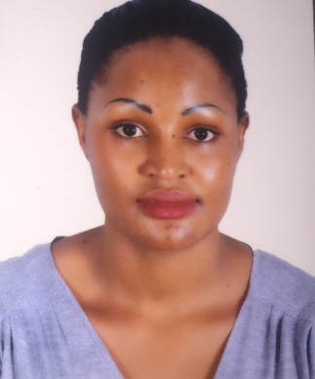

***NABULYA***

WAITRESS

***Personal Summary***

To obtain a challenging position in a company where i can untilize my knowledge and experience to provide friendly, responsive service to create an exceptional dining experience for all of our guests.

***Duties***

* Welcoming customers to the hotel.
* Greeting customers with a big smile.
* Escorting them to their seats.
* Offering them menus.
* Help him/her pass through the menu.
* Write down orders accurately and read through what he/she has ordered.
* Serving him/her what she/he has ordered accurately and in time.
* Liaising with customers by informing them of the daily special meals and when they are served.
* Cleaning tables by taking away what customers are done using.
* Collect bills from customers.
* Remove dishes and glasses from tables or counters, and take them to kitchen for cleaning.
* Fill salt, pepper, sugar, cream, condiment, and napkin containers.
* Making sure the dining room is presentable.
* Performing side work tasks, and some cleaning.
* Handling cash, checks, and credit.
* Well aware of safety information about all materials used within the scope of the work
* Able to read, write, and communicate in English
* Able to carry out all job functions safely
* Excellent attention Detail
* Able to follow instructions
* Good ability to use equipment and tools used to do the job
* Motivated, Reliable, Hard working, Passionate and friendly.
* Ability to deal with difficult customers.
* Proud to wear uniforms because it creates a professional environment.
* Ability to work as a team.

***AREAS OF EXPERTISE***

*Hospitality Industry*

*Customer service*

*Knowledge of food & beverages*

***WORK EXPERIENCE***

***Company****: Lake Victoria Serena Hotel*

***Duration****:2014-2016*

***Role****:* **Waitress**

***Company: City Food Restaurant***

***Duration****:***2013-2014**

***Role****:* **Waitress**

***KEY SKILLS***

*Excellent interpersonal skills*

*Patient with customers*

*Passion for work*

*Good time management*

*High degree of self motivation*

***PERSONAL DETAILS***

***Visit Visa******Female***

***Ugandan***

***D.O.B 19 -09- 1990***

[*Nabulya.380815@2freemail.com*](mailto:Nabulya.380815@2freemail.com)

***Languages***

* English fluent

***Hobbies***

* Researching
* Adventure
* Making friends
* Team work

**Referees**

* Available upon request

***Educational Background***

*High School Certificate*

***Other Trainings***

Customer care certificate