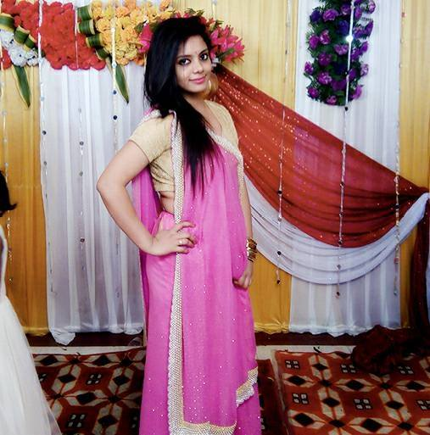

Shahina

Fashion Designer

DOB-30 Jan 1992

Email: [shahina.380820@2freemail.com](mailto:shahina.380820@2freemail.com)

|  |  |  |
| --- | --- | --- |
|  | Education |  |
|  |  |
| 10th  Indian Public School  Madhubani  2007 | 12th  Ishaan International Public School  Patna  2009 | Bachelor of Design  National Institute of Fashion technology  Kolkata  2010-2014 |

|  |  |  |
| --- | --- | --- |
|  | Objective |  |
|  |  |
| A highly self-motivated Fashion Design Graduate from **National Institute of Fashion Technology, Kolkata** **(2010-2014)**, with an objective of gaining experience and seeking an opportunity to apply my design and merchandising skills to experience and serve further as a design professional in Textile and Fashion industry, based on company’s brand philosophy. Looking forward to an experience to develop myself further with my contribution to the company and hence, the industry at large. | | |

|  |  |  |
| --- | --- | --- |
|  | Key Skills |  |
|  |  |
| Professional  Word  Excel  Photoshop  Corel Draw | Related  Draping  Pattern making  Construction  Illustrations  Design development | Personal  Sketching  Surface ornamentation Styling  Music  Sourcing |

|  |  |  |
| --- | --- | --- |
|  | Graduation project |  |
|  |  |
| Four months’ project in Indo-Western Women’s wear based on thematic approach, including Swatch Developments and Documentations, Doodling, Mind Mapping, Illustrations for the domestic/international market in National Institute of Fashion Technology ,Kolkata | | |

|  |  |  |
| --- | --- | --- |
|  | Internship Project |  |
|  |  |
| Two and half months’ summer internship programme at **Modelama Export House,Gurgaon,India** (2012) where I worked as an Assistance Designer for women’s western wear and Accessories to suit industry design requirements, to adjust and adapt to a new environment, to learn, understand and applications of theoretical knowledge to the real factory world. | | |

|  |  |  |
| --- | --- | --- |
|  | Experience |  |
|  |  |
| ** Worked as Fashion designer in **CHASE LIYESTYLE PVT. LTD** for 3 years and 6 months.  ** BACKSTAGE at **Lakme Fashion Week** , Kolkata in 2011  **Cluster Project at **PHULIA** for exploring Bengal art and submitting a report at NIFT, Kolkata.  ** Assistance fashion designer at ASHISH SAHANI (Kolkata based designer) for 6 months.  **Assistance fashion designer in **M.H.Creation** where I learnt different embroidery skills and technique for 6 months. | | |

|  |  |  |
| --- | --- | --- |
|  | Projects exposure |  |
|  |  |
| The Integrated Term Projects (ITP) undertaken in each semester at NIFT, which incorporated thematic approach, market study, design developments, inspirations board, doodling , illustrations ,mind mapping, color board, mood board, theme board, design approval by the selected mentors and hence development of the product or an ensemble.  **CLUSTER DEVELOPMENT**  Team work development in Garments, Bags and Accessories using Kantha and Batik techniques, with thematic approach and documentations done. Taking inspirations from local handicraft works, techniques, procedures and adapting it to suit modern day market trends and demands, with the help of local Shantiniketan artisans. | | |

|  |  |  |
| --- | --- | --- |
|  | Responsibilities |  |
|  |  |

**Product sampling**

* Development of Fit Sample, Size Set Sample, Pre-production Sample, Shipment Sample in accordance with the Order requirements.
  + Sample development as per the Range Plan and pre-season planning.

**Product merchandising**

• First point of contact with the Buyers from the Sampling stage to Shipment stage.

• Co-ordination with the various departments involved with the Production and ensuring hassle free production which meets the timeline sand quality standards.

**Business Development**

• Business volume enhancement with the existing Buyers, by introducing new product lines.

**ACHIEVEMENTS**

**Won certificates and awards for music competition as well as solo acting at school level.

** Won medal for 1st runner up at college fest (Spectrum) for music competition.

** Won Rangoli competition at office in Deewali.

|  |  |  |
| --- | --- | --- |
|  | Current Status |  |
|  |  |
| **Left job at **Chase lifestyle Pvt. Ltd** as fashion designer for Women’s western wear in March 2018 and came to Dubai for a new job on visit visa for three months. | | |