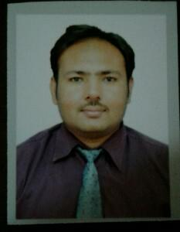
Qamar

Qamar.380826@2freemail.com

CAREER OBJECTIVE

As I am the fresher in this field, I will know about the nature of my work. Moreover, I will attempt to know about the various processes which form my job. By doing so, I will be able to do my job more proficiently. On the other hand, I shall implement my knowledge into the practical world.

PERSONAL DETAILS

Date of birth

28/04/1987

Gender

Male

City

Dubai

Nationality

Pakistan

Marital Status

Married

Religion

Islam

Languages known

Arabic, English and Urdu

Hobby

Internet surfing

WORK EXPERIENCE

Co-ordinator

Sheta & saif Riyadh Saudi Arabia

Dec 2011 - Aug 2015

To maintain the accounts, appointments with the honourable customers & motivate the installation team to enhance the sales and to provide after sales service to customers.

EDUCATION DETAILS

Degree/Course | Institution | University/Board | CGPA/Percenta | Year of Passing
 |  |  | ge
B.com | Govt college of | University of | 50.8% | 2009
 | commerce | Punjab

 | Faisalabad
Pipfa | Tips college of |  | % | 2009
 | commerce
 | Faisalabad
F.sc (pre- | Govt.college | Faisalabad | 58% | 2006
medical) | university, | board
 | Faisalabad
Matriculation(sci | M.c.high | Faisalabad | 63% | 2004
ence ) | school,factory | board
 | area,Faisalabad

SKILLS

Computer Ms office

Tally

Microsoft Outlook

Driving licence L.t.v Saudi Arabian driving licence

Abilities Quick learner, Team leader & like to work under pressure

Problem solving Able to deal with the problems calmly and effectively

Communication Confident verbal & writing skills

Team work Accustomed to working in groups, worked effectively as a part of team

Strengths Honesty

Calm attitude

Never give up

Weaknesses Emotions

Inability to say no

Overthinking

DECLARATION

I hereby declare that the above cited information is true to the best of my knowledge and belief, if given a chance, I can prove myself.

Powered by TCPDF (www.tcpdf.org)

