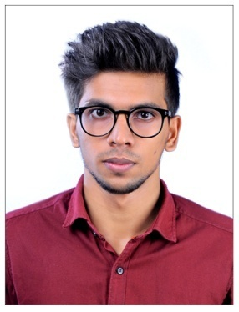NIJIL
MECHANICAL ENGINEER

Email Id: nijil.380832@2freemail.com

CAREER OBJECTIVE

To obtain a creative and challenging position in an organization that gives me an opportunity for self-improvement and leadership, while contributing to symbolic growth of the organization with my technical, innovative and logical skills.

PROFFESSIONAL EXPERIENCE

- Worked as Service Supervisor at HONDA (From 04/09/2017 to 15/11/2017)

PERSONAL SKILLS

- Self-confident and self-motivated.
- Deterministic & optimistic.
- Good communication skills with ability to influence others.

PERSONAL PROFILE

- Date of Birth : 27-07-1995
- Sex / Marital Status : Male / Single
- Nationality / Religion : Indian / Hindu
- Languages Known : English , Malayalam , Hindi

EDUCATION QUALIFICATION
Course |  | Board/University | Institution | Percentage
SSLC |  | Kerala Board of Public Examination | SABTMHS Thayineri | 79%
PLUS TWO |  | KERALA STATE | GHSS Vellur | 73%
B-Tech in Mechanical Engg | Kannur University |  | SREE NARAYANA GURU COLLEGE OF ENGINEERING AND TECHNOLOGY PAYYANUR | 60%

ADDITIONAL QUALIFICATION

- Certification in Oil and Gas Engineering
- Certification in NDT Level II , PIPING and QC Engineering

TECHNICAL ACTIVITIES
Industrial Training | 9days of industrial training at Cochin Shipyard Ltd
Projects | Design And Fabrication Of Agriculturally Modified Multipurpose All Terrain Vehicle
Paper Presentations | Presented a paper “Design And Fabrication Of Agriculturally Modified Multipurpose All Terrain Vehicle ” in 3rd National Conference On Technological Advancement in Engineering, Dept of Mechanical Engg, SNGCET Payyannur

