Mary
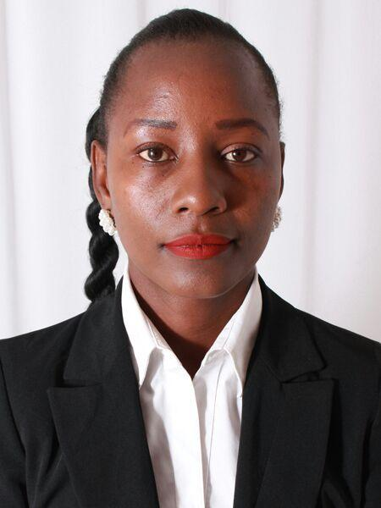
Email : mary.380848@2freemail.com
Nationality: Kenyan.
Languages: Fluent English & Mandarin.
Visa Status: Resident Visa( Transferable)

CAREER OBJECTIVE.

I aspire for a challenging position in a professional organization where I can enhance professional skills, add value to the Company as well as strengthen my performance. I am a hardworking professional committed to making a positive difference in your Company. I am a flexible and dedicate myself to the job and focus on delivering quality results.

KEY STRENGTHS.

- Excellent verbal and written communication skills.
- People’s person with great customer service & negotiation skills.
- Detail oriented with excellent analytical skills.
- Great team player with excellent organization and leadership skills.
- Possess leadership skills, organizational and time management skills

WORK HISTORY.
March 2017 –to- date: Ansar Group of Companies .
Cashier/Sales Executive.

Duties & Responsibilities.

- Taking full responsibility for the cash and till management under my custody as a Cashier.
- Billing items and ensure pricing is correct and giving correct balances to the customers.
- Receive payments inform of cash, credit cards, vouchers among other methods.
- Making daily sales cashier summary report.
- Serving clients diligently and answering any questions they may have
- Offering information to Customers regarding the available offers and promotions and new products introduced and convincing them to purchase.
- Generating leads on prospective areas to help meet and even exceed our sales target.
- Stocking the shelves and bar-coding items.
- Helping determine pricing schedules for quotes, promotions, and negotiations.
- Preparing weekly sales reports and determining if target is achieved.
- Giving sales presentations for new products introduced.

July 2013-December 2016: Sarova Hotels.
Beverage Server

Duties & Responsibilities.
- Welcoming guests into the Hotel and directing them to their seats accordingly.
- Presenting menu, answering questions and offering suggestions to guest.
- Takes orders from guests, serves food and beverages as per Hotel standards and ensuring hygiene is observed at all times.
- Checking guest satisfaction from time to time and ensuring they are well catered for during the duration of their stay.
- Ensuring bills are presented in a timely manner and that all orders are properlly listed and correctly priced
- Maintains high standards of hygiene and orderliness
- Anticipates guest needs, offers suggestions and ascertains satisfaction
- Explaining food & beverage menu items in a concise, informative and appropriate manner
- Highly sensitive to guest preferences; assists in compiling guest history; offers a special service touch when an opportunity is presented
- Accurately posts guest checks, processes payments and adheres to related control procedures in a vigilant manner
- Resolve any issues that may arise making sure guest leave happy

March 2011- July 2013: Indaa Park Launch & Grill
Front desk.
- Register & process guests and their assigned rooms.
- Accommodate guest requests.
- Communicating with hotel staff on the status of guest rooms
- Up Selling guest rooms and promoting hotel services
- Handling cash payments
- Maintain a clean and neat front desk area.
March 2008-March 2011: Renco Car Identity Co Ltd
Sales Executive.

- Selling and marketing of assorted motor accessories.
- Coordinating a team of staff who were the task-force behind fitting of accessories, car wash and other minor lube services.
- Handling of account books
- Maintained a highly skilled and competent workforce offering superb services thus leading to achievement of work objectives.
- Provided excellent leadership and supervision to my work colleagues leading to harmonious working relations and smooth work flow.
- Translated the knowledge into practical initiatives that made great improvement in business performance.

EDUCATION HISTORY.

May 2009 –to- May 2010 : EAST AFRICA UTALII INSTITUTE.
Diploma in Tours & Travel.

January 2009 – May 2009: INSTITUTE OF ADVANCE TECHNOLOGY
Certificate in International Computer Driving License.

January 2005- DEC 2008 SECONDARY EDUCATION
Attained A Pass

