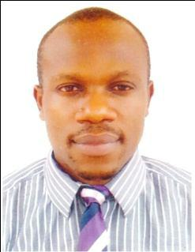
Dr. Maximus

Email: maximus.380863@2freemail.com
Nationality: Nigerian

A highly personable, competent and diligent optometrist with extensive experience in hospital settings. Competent at examining, diagnosing, treating patients with abnormalities. Seeking an opportunity to fully utilize my knowledge and expertise.

CORE COMPETENCIES

✓ L o w Vi s i o n A s s e s s m e nt

- Opthalmoscopy

- Refraction

- Retinoscopy

PROFESSIONAL EXPERIENCE

Nationale Eye Centre, Abuja. January, 2017 – February 2018.

Optometrist

- Responsible for assessment and treating of patients with Hypermetropia, Myopia, Presbyopia, Astigmatism.

Federal Medical Centre – Makurdi. October 2015 – October 2016

Corper Optometrist

- Responsible for diagnosing and treating ocular abnormalities.

- Made recommendations and counseled patients regarding correct healthcare practices.

Assumpta Eye Clinic, Owerri. October 2014 – September 2015.

Optometrist Intern

- Responsible for diagnosing and treating ocular abnormalities.

- Made recommendations and counseled patients regarding correct healthcare practices.

EDUCATION

Doctor of Optometry (OD), Imo State University, Owerri, Imo State, Nigeria, 2013.

Senior Secondary School Certificate, Community Secondary School Emekuku Owerri, Nigeria, 2002.

First School Leaving Certificate, Uwaorie Primary School, Agwa Imo State, Nigeria. 1993.

PERSONAL DETAILS

Date of Birth: March 23, 1988

Gender: Male

Relationship Status: Single

